Construct the circuit shown below:-
R | Theoretical Value (Kohm) | Measured Value
R1 | 3.3
R2 | 6.2
R3 | 1.2
R4 | 2.7
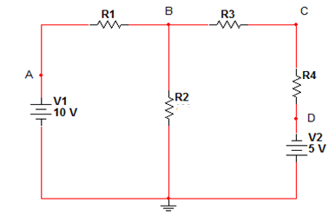

- Nodal Analysis:
Value | VA | VB | VC | VD
Measured
Theoretical

- Use the Nodal Analysis to find the theoretical values.

- Superposition Analysis:
Value | $${VB}^{'}$$ | $${VB}^{''}$$ | $${VC}^{'}$$ | $${VC}^{''}$$ | $${I1}^{'}$$ | $${I1}^{''}$$ | $${I2}^{'}$$ | $${I2'}^{'}$$
Measured
Theoretical

- Use the Superposition Analysis to find the theoretical values.

