- Construct the circuits shown below and answer the following questions.
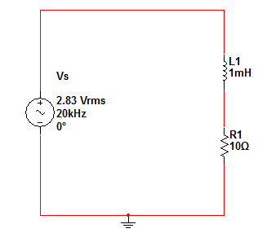
- RL Circuit
- $V_{L} \left[ lag, Lead, In phase\right]with I_{L} ?$
- $Find the magnitude of V_{L} , V_{R} and I_{L} ?$
- $Find the phase shift between V_{s} and I_{s} ?$
- $Plot V_{s} and I_{s} on the same graph ?$

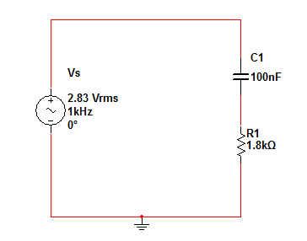
- RC Circuit

- $V_{C} \left[ lag, Lead, In phase\right]with I_{C} ?$
- $Find the magnitude of V_{C} , V_{R} and I_{C} ?$
- $Find the phase shift between V_{s} and I_{s} ?$
- $Plot V_{s} and I_{s} on the same graph ?$

