

T103/TM103
Computer Organization and Architecture
Midterm Examination (MTA)
Solution
Fall Semester 2023/2024

Date: ?? /xx./2023

Time Allowed: 1.5 Hours | Number of Exam Pages: 4  (including this cover sheet)

Instructions:
- Total Marks: 60
- This exam consists of two parts.
- ALL questions must be answered in the External Answer booklet.
- Be sure you write your name and ID on the External Answer booklet.
- Programmable Calculators are not allowed.

Part 1: Multiple Choices questions (5 x 2 = 10 Marks)

Answer all the following questions by choosing the most correct statement
- For the AND gate, the output will be 0 if:

- All inputs are 1, exclusively.
- All inputs are 0, exclusively.
- Only when inputs have different values.
- None of the choices.

- Which 2-input logic gate produces a 1 output when any one of its inputs is 1, but not both?

- AND.
- XOR.
- NOR.
- NAND.

- In the SR-Flip Flop, if R=0, S=1 then:

  - Q(t+1) is unknown.
  - Q(t+1)= Q’(t)
  - Q(t+1)= 1
  - None of the choices.

- What decimal value does the 8-bit binary number 10111010 represent, if the computer is using a C1 representation?

- -58.
- 58.
- -69.
- -186.

- A Multiplexer with 60 inputs needs at least:

- 8 selectors
- 4 selectors
- 16 selectors
- 6 selectors.

PART 2: ALL QUESTIONS ARE REQUIRED [50 Marks]
Remark for questions in Part 2:
All the answers below for the questions are considered ideal answers to be considered in correction. However, the tutor should expect student’s answers to be provided in a different style and format. Kindly consider these answers and allow for partial marks to be awarded accordingly.

Q-1: Using truth table, check whether F= x’+yz’, and G= x(y’+z) are complements to each other or not. [6 marks]

Answer: (6 marks: 2.5 marks for each T.T; 1 mark for the conclusion)

Inputs |  |  | Intermediate |  |  | F | Intermediate |  | G
x | y | z | x’ | z’ | yz' | x' +yz' | y’ | y'+z | x(y'+z)
0 | 0 | 0 | 1 | 1 | 0 | 1 | 1 | 1 | 0
0 | 0 | 1 | 1 | 0 | 0 | 1 | 1 | 1 | 0
0 | 1 | 0 | 1 | 1 | 1 | 1 | 0 | 0 | 0
0 | 1 | 1 | 1 | 0 | 0 | 1 | 0 | 1 | 0
1 | 0 | 0 | 0 | 1 | 0 | 0 | 1 | 1 | 1
1 | 0 | 1 | 0 | 0 | 0 | 0 | 1 | 1 | 1
1 | 1 | 0 | 0 | 1 | 1 | 1 | 0 | 0 | 0
1 | 1 | 1 | 0 | 0 | 0 | 0 | 0 | 1 | 1

F and G columns show that the two functions have opposite outputs, Hence, G is the complement of F.

Q-2: Given the circuit below that implements the Boolean expression F. [6 marks]
    - Write the equation of F.
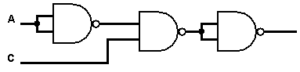
    - What will be the value at the output if the input values are: A=0, C=1? Justify your answer.
Answer: (6 marks: 3 +3)

- $F\left(x, y\right)=\overset{̿}{\left(\overline{A}.C\right)}$ , or (A’.C) (3 marks)

- The output will be 1 (2 marks), because A’=1 and C=1 then A’C=1. (1 mark)

Q-3: Represent the decimal number (-79) in: [11 marks]

- Signed Magnitude 8-bit representation.
- Two’s Complement 8-bit representation.
- Excess-16 Floating point representation.

8-bit signed magnitude | 11001111 |  |  |  |  |  |  |  |  |  |  |  |  |  | [3 marks]
two’s complement | 10110001 |  |  |  |  |  |  |  |  |  |  |  |  |  | [3 marks]
Excess-16 FP | 1 | 1 | 0 | 1 | 1 | 1 | 1 | 0 | 0 | 1 | 1 | 1 | 1 | 0 |  | [5 marks]

Q-4: Given the following F in its Sum of Product form: [12 marks]

F(x,y,z)_{SoP}= x’y’z’ + x’yz + x’yz’+ xy’z’ + xyz + xyz’

- Draw the K-Map of the function “F”.
- Show the grouping that you selected for simplifying the function.
- Write the simplified F.

Answer:

- (4 marks)
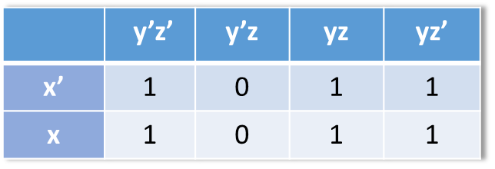
- (4 marks for the proper grouping)
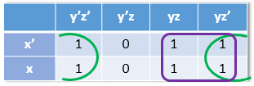
- F= y + z’ (4 marks: Deduct 1 mark if the student added a redundant term)

Q-5: Perform the following base conversions: [15 marks]
- (116.25)₁₀ = (1110100.01)₂ [3 marks]
- (11001101.110)₂ = (315.6)₈ [3 marks]
- (3D.C)₁₆ = (61.75)₁₀ [3 marks]
- (3D.C)₁₆ = (111101.11)₂ = (75.6)₈ [6 marks: 3+3]
___________________________________________________________________________
End of questions

