1. **Transient RL Circuit**
2. Construct the following circuit.

|  |  |  |  |
| --- | --- | --- | --- |
| Element | Unit | Theoretical | Measured |
| R1 | KΩ |  |  |
| R2 | Ω |  |  |
|  | Ω |  |  |
| L | mH |  |  |
|  | s |  |  |

1. 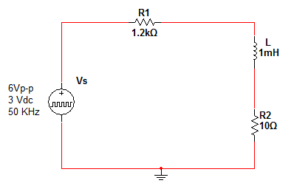Measure the internal resistance of the inductor.
2. Calculate the time constant
3. Draw the inductor current & evaluate it at t=
4. Draw the voltage source and inductor voltage in the same graph.

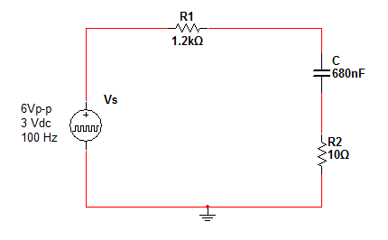

1. **Transient RC Circuit**
2. Construct the following circuit.
3. Calculate the time constant
4. Draw the capacitor voltage & evaluate it at t=
5. Draw the voltage source and capacitor current in the same graph.