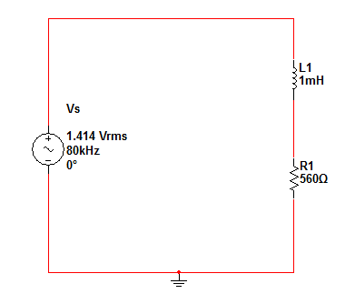**Part A:**

* Fill the table below?

|  |  |
| --- | --- |
| Quantity | Value |
|  |  |
|  |  |
|  |  |
|  |  |
|  |  |
| PF= Cos |  |

* Display Vs and on the same screen then find ?
* Find

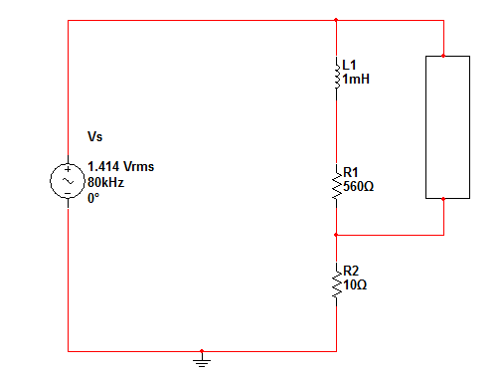**Part B:**

* Calculate the reactance load that makes PF near unity?
* The load will be --------------- and it has the value of -------------.

**L**

**O**

**A**

**D**

* Construct the circuit with the Load then finding the quantities in the table?

|  |  |
| --- | --- |
| Quantity | Value |
|  |  |
|  |  |
|  |  |
|  |  |
|  |  |
| PF= Cos |  |

* Find