* **Implement the following circuit on the bread board.(V1=10V)**

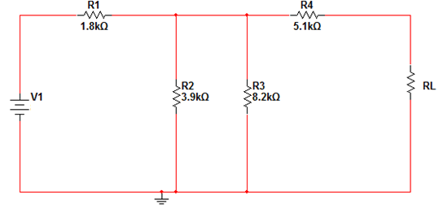

1. Based upon the circuit above, find the following parameters experimentally.

|  |  |  |  |
| --- | --- | --- | --- |
| Parameter | Vth |  | Rth |
| Measured Value |  |  |  |
| Theoretical Value |  |  |  |

1. Use the potentiometer as a load then fill the table below.

|  |  |  |
| --- | --- | --- |
| (KΩ) |  | (mW) |
| 3KΩ |  |  |
| 6 KΩ |  |  |
| 9 KΩ |  |  |

1. Draw the power consumed by the load ) against .
2. Draw the Thevenin equivalent circuit.
3. Draw the Norton equivalent circuit.
4. Determine which resistor consumes the largest power from the second table.
5. Is this formula verified the maximum power calculated from your measurements? If yes, prove that.