General Instructions

Lab Safety Precautions
- Familiarize yourself with the location of fire extinguishers, safety showers, fire blankets and eye wash fountains and know how and when to use these devices.
- When heating a test tube or carrying out a reaction in one, never point the tube toward yourself or your neighbor.
- Always turn a burner off as soon as you finish using it.
- As a general practice, and particularly if a burner is in use, avoid loose- fitting long sleeves and cuffs. Long hair should be tied back during laboratory work.

Laboratory rules
- Each student is expected to attend each lab session and to be in the laboratory on time. Those students, who come early, should wait inside the lab but never gather in the corridors.
- Each student must wear a clean and buttoned up lab coat with his\here tag name before enter your lab.
- Skirt, short clothe, sandal (open shoes) and head caps forbidden in lab.
- Smoking, Drinking, Eating or Chewing gum is prohibited in the lab.
- Each student is responsible for keeping the laboratory clean and in good order.
- Coats, book and personal belongings should be kept in your lockers. Do not bring them with you to the lab.
- All working areas must be kept clean.
- If students are assigned to work as groups, each group is expected to work quietly and independently.
- Do not carry reagent bottles to your desk.
- Never return excess materials to reagent bottles.
- Each student must bring:

- Permanent Marker
- Calculator
- lighter

You Will Be Held Responsible for Each Rule Mentioned Above, Any Violation Will Expose You to Either Being Dismissed from The Lab or Losing Evaluation Marks of That Particular Experiment Without Prior Notification

Experiment 1
ORIENTATION TO THE PHARMACEUTICAL MICROBIOLOGY LABORATORY

Introduction

Safety procedures and precautions
The microbiology laboratory, whether in a classroom or a working diagnostic laboratory, is a place where cultures of microorganisms are handled and examined. This type of activity must be carried out with good aseptic technique in a thoroughly clean, well-organized workplace. In aseptic technique, all materials that are used have been sterilized to kill any microorganisms contained in or on them, and extreme care is taken not to introduce new organisms from the environment. Even if the microorganisms you are studying are not usually considered pathogenic (disease producing), any culture of any organism should be handled as if it were a potential pathogen. This mean that, although they may not cause disease in normal healthy host, they might if the host can be compromised in number of different ways: wounds and cuts, lowered resistance due to another disease, surgery, stress (including stress examination), or immune –system disability (including autoimmune disease or the use of immunosuppressive drugs).in addition infection can occur, albeit rarely, by relatively nonpathogenic organisms even in healthy hosts.

Each student must quickly learn and continuously practice aseptic laboratory technique. It is important to prevent contamination of your hands, hair, and clothing with culture material and also to protect your neighbors from such contamination. In addition, you must not contaminate your work with microorganisms from the environment. The importance of asepsis and proper disinfection is stressed throughout this manual and demonstrated by the experiments. Once these techniques are learned in the laboratory, they apply to almost every phase of patient care, especially to the collection and handling of specimens that are critical if the laboratory is to make a diagnosis of infectious disease. These specimens should be handled as carefully as cultures so that they do not become sources of infection to others.
In general, all safety procedures and precautions followed in the microbiology laboratory are designed to:

- Restrict microorganisms present in specimens or cultures to the containers in which they are collected, grown, or studied.
- Prevent environmental microorganisms (normally present on hands, hair, clothing, laboratory benches, or in the air) from entering specimens or cultures and interfering with results of studies.

In addition to microorganism, there are some chemicals used in the laboratory which are potentially harmful. Safety is a very important requirement for work in chemical laboratories.
Sometimes you'll be working with toxic materials, flammable liquid and explosive compounds. If all important precautions are not taken into consideration, then hazardous accidents will occur.

Microbiology Lab Practices and Safety Rules

The following rules are very important for your safety as well as the safety of other students. follow them each laboratory. Read them carefully and Please Warning Some of the laboratory experiments included in this text may be hazardous if you handle materials improperly or carry out procedures incorrectly.

- Careful attention to the principles of safety is required throughout any laboratory course in microbiology.
- Laboratory coats are worn, long hair is tied back
- Avoid loose fitting items of clothing. Wear appropriate shoes (sandals are not allowed) in the laboratory
- Wash your hands with disinfectant soap when you arrive at the lab and again before you leave.
- Absolutely no food, drinks, chewing gum, or smoking is allowed in the laboratory. Do not put anything in your mouth such as pencils, pens, labels, or fingers. Do not store food in areas where microorganisms are stored.
- Personal conduct in a microbiology laboratory should always be quiet and orderly.
- Any student with a fresh, unhealed cut, scratch, burn, or other injury on either hand should notify the instructor before beginning or continuing with the laboratory work. If you have a personal health problem and are in doubt about participating in the laboratory session, check with your instructor before beginning the work.
- Keep your workspace free of all unnecessary materials. Backpacks, purses, and coats should be placed in the cubbyholes by the front door of the lab. Place needed items on the floor near your feet, but not in the aisle.

- Disinfect work areas before and after use with 70% ethanol or fresh 10% bleach. Laboratory equipment and work surfaces should be decontaminated with an appropriate disinfectant on a routine basis, and especially after spills, splashes, or other contamination.
- Familiarize yourself with the location of safety equipment in the lab (e.g., eye-wash station, shower, sinks, fire extinguisher, biological safety cabinet, first aid kit, emergency gas valve).
- Containers used for specimen collection or culture material are presterilized and capped to prevent entry by unsterile air, and sterile tools are used for transferring specimens or cultures.
- Treat all microorganisms as potential pathogens. Use appropriate care and do not take cultures out of the laboratory.
- Wear disposable gloves when working with potentially infectious microbes or samples (e.g., sewage). If you are working with a sample that may contain a pathogen, then be extremely careful to use good bacteriological technique.
- Never pipette by mouth. Use a pipetting aid or adjustable volume pipettors. [In the distant past, some lab personnel were taught to mouth pipette. This practice has been known to result in many laboratory-acquired infections. With the availability of mechanical pipetting devices, mouth pipetting is strictly prohibited]
- Consider everything a biohazard. Do not pour anything down the sink. Autoclave liquids and broth cultures to sterilize them before discarding.
- Dispose of all solid waste material in a biohazard bag and autoclave it before discarding in the regular trash.
- Replace caps on reagents, solution bottles, and bacterial cultures. Do not open Petri dishes in the lab unless absolutely necessary.
- Inoculating loops and needles should be flame sterilized in a Bunsen burner before you lay them down.
- Turn off Bunsen burners when not in use.
- When you flame or sterilize with alcohol, be sure that you do not have any papers under you.
- Dispose of broken glass in the broken glass container.
- Dispose of razor blades, syringe needles, and sharp metal objects in the “sharps” container.
- Report spills and accidents immediately to your instructor. Clean small spills with care (see instructions below). Seek help for large spills.
- Report all injuries or accidents immediately to the instructor, no matter how small they seem.
- Label everything clearly.

Labeling:
You must carefully label your plates and tubes. There will be a lot of plates and test tubes incubating together making clear labeling crucial to avoid chaos. Always label the BOTTOM of the plate so that, even if lids get accidentally switched or broken, we will know what was in each plate. Likewise, do not label tubes on the cap. The label should include your name, the date the plate was struck, and what was put into the plate (microbe name).

Handling and Examining Cultures

Microscopic examination of microorganisms provides important information about their morphology but does not tell us much about their biological characteristics. To obtain such information, we need to observe microorganisms in culture. If we are to cultivate them successfully in the laboratory, we must provide them with suitable nutrients, such as protein components, carbohydrates, minerals, vitamins, and moisture in the right composition. This mixture is called a culture medium. It may be prepared in liquid form, as a broth, or solidified with agar, a nonnutritive solidifying agent extracted from seaweed. Agar media may be used in tubes as a solid column or as slants, which have a greater surface area. They are also commonly used in petri dishes, or plates.
Solid media are essential for isolating and separating bacteria growing together in a specimen collected from a patient, for example, urine or sputum. When a mixture of bacteria is streaked across the surface of an agar plate, it is diluted out so that single bacterial cells are deposited at certain areas on the plate. These single cells multiply at those sites until a visible aggregate called a colony is formed. Each colony represents the growth of one bacterial species. A single, separated colony can be transferred to another medium, where it will grow as a pure culture. Colonies of several different species are regularly present on the same agar plate when certain patient specimens are inoculated onto them. Working with pure cultures permits the microbiologist to study the properties of individual species without interference from other species.
The appearance of colonial growth on agar media can be very distinctive for individual species. Observation of the noticeable, gross features of colonies, that is, of their colonial morphology, is therefore very important. The color, density, consistency, surface texture, shape, and size of colonies all should be observed, for these features can provide clues as to the identity of an organism, although final identification cannot be made by morphology alone. In liquid media, some bacteria grow diffusely, producing uniform clouding, whereas others look very granular. Layering of growth at the top, center, or bottom of a broth tube reveals something of the organisms’ oxygen requirements. Sometimes colonial aggregates are formed and the bacterial growth appears as small puff balls floating in the broth. Observation of such features can also be helpful in recognizing types of organisms.

Hygienic practices

Hygiene is a set of practices performed for the preservation of health. According to the World Health Organization (WHO), "Hygiene refers to conditions and practices that help to maintain health and prevent the spread of diseases.

A. Surface hygiene.
B. Disinfection of cleansing tools.
C. Hand hygiene (For types of hand hygiene (see table below))

Disposal of Laboratory Wastes and Cultures During laboratory practices

it has been noticed that the untreated waste is generally disposed off by the laboratory staff. It happens due to their unskilled work culture. Any material which contains microorganisms should be treated first and thereafter, with the proper treatment should be thrown properly. The treatment is necessary due to the reasons:
a) If it contains pathogenic microorganisms, the disease may transmit or spread to the healthy persons.
b) It may contaminate soil and causes soil, water and air-pollution. Hence, to check from such hazards, proper treatment is required to kill microorganisms.

The infected material is generally the solid or liquid culture media used for cultivation of microorganisms, or it may also contain cotton plugs, paper, cotton or cotton swabs, gloves, pins, PCR tubes, gel material etc. Some of the materials such as cotton plugs, paper, napkins, swabs etc. should be autoclaved first and then it is incinerated. But the microbial contaminants containing materials should be treated with some disinfectant and thereafter autoclaved by putting them in suitable containers. The molten material should be discarded.

Sometimes, HCl is also added to hydrolyze the agar, if present in the medium. This is added before their safe disposal. All such laboratory materials should be disposed of after autoclaving.

Tools in Microbiology Laboratory The most common equipment are inoculation needle, inoculation/transfer loop, Bunsen burner, autoclave (or pressure cooker), incubator, hot air oven, refrigerator, centrifuge, spectrophotometer, magnetic stirrer, orbital shaker, hot plate, Distillation water still, UV- lamp, water-bath, carbon dioxide cylinder, single-pan balance with weights (for rough use), chemical balance, pH meter, colony counter, laminar air flow, electrophoretic apparatus, microscopes etc.

- Inoculation Needle & Inoculation Loop:

- These are the most commonly used tools.
- Inoculation needle/loop is made up of a long platinum wire fixed into a metallic rod.
- A wire loop has a handle with steel screw shaft in which nichrome or platinum wire is to be fitted.
- The straight wire needle is used for transferring culture from solid medium. Even smaller amount of liquid culture can be manipulated by using straight needle.
- The loop and wire are also used for picking small quantities of solid materials from a microbial colony and can be used to inoculate either a liquid or a solid medium. Both the loop and straight wire must be flamed immediately after use to avoid contamination.
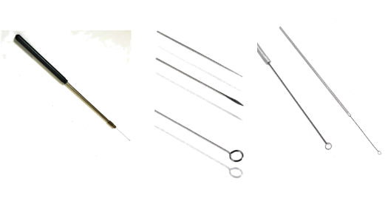
- Bunsen Burner:

- Sterilization of tools by using spirit lamp is called incineration.
- Gas enters the burner at the base, and its supply is regulated externally by the gas cock.
- The amount of air can be controlled by rotating a sleeve that fits over the holes in the body of the burner.
- To keep the flame from blowing out special tips are frequently used to fit over the top end of the barrel.
- The proper method of lighting the burner is to close off the air supply, turn on the gas and light. The flame will be large and yellow. Gradually open the air intake until the flame takes a blue color.
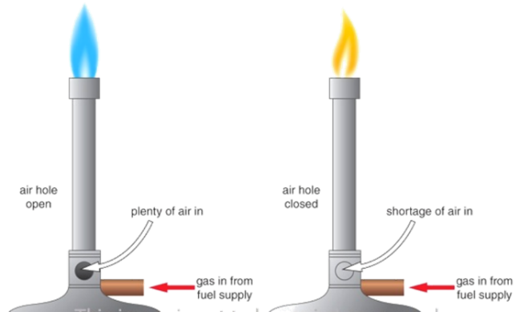

- Laminar Air Flow Chamber:

- Laminar air flow is an apparatus consists of an air blower in the rear side of the chamber which can produce air flow with uniform velocity along parallel flow lines. There is a special filter system of high efficiency particulate air filter (HEPA) which can remove particles as small as 0.3 mm.
- In front of the blower, there lies a mechanism through which air blown from the blower produces air velocity along parallel flow lines.
- The laminar air flow is based on flow of air current of uniform velocity along parallel flow lines which help in transferring microbial cultures in aseptic conditions. Air is passed through the filters into the enclosure and the filters do not allow any kind of microbe to enter in to the system.
- Inside the chamber one fluorescent tube and another UV tube are fitted. Two switches for these tubes and a separate switch for regulation of the air flow are fitted outside the LAF. Due to uniform velocity and parallel flow of air current, pouring of media, plating, slant preparations, streaking etc. are performed without any kind of contamination.
- Initially, dust particles are removed from the surface of the laminar air flow with the help of smooth cloth containing alcohol. Switch on the UV light for a period of 30 minutes so as to kill the germs, if any present in the area of working space.

- The front cover sheet of the apparatus is opened to keep the desired material inside. The air blower is set at the desired degree so that the air inside the chamber is expelled because the air inside the chamber may be contaminated / bring contaminants.

- In microbiology laboratory, horizontal type of laminar air flow is used to supply the air through filter.
- Precautions: Wash the hands with detergents or soap before entering to operate the apparatus. One should not talk inside the chamber while performing microbial culture transfer, failing which chances of contamination may be more which may come either through mouth, sneezing or air
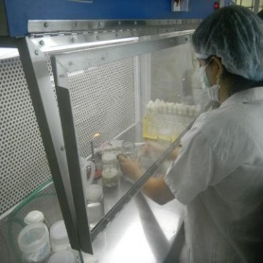
- Incubator:
- An incubator is an instrument that consists of copper/steel chamber around which warm water or air is circulated by electric current or by means of small gas flame.
- The temperature of the incubator is kept constant due to its control by using thermostat.
- Temperature greatly influences the microbial growth. Therefore, instrument is generally designed that can allow the desired microorganism to grow at a particular temperature.
- Precautions: the door of the incubator should be opened only when necessary. If the tubes are to be incubated for a long time or at higher temperature, the medium may become too dry due to excessive evaporation. In such cases cotton plug should be pushed inside the neck of the tube. The tube should be covered by a rubber cap so as to cover the plug. If the petriplates are to be incubated for a long time, they may be placed in moist chamber with a damp sterile cotton wool at the bottom.

- The Microscope:

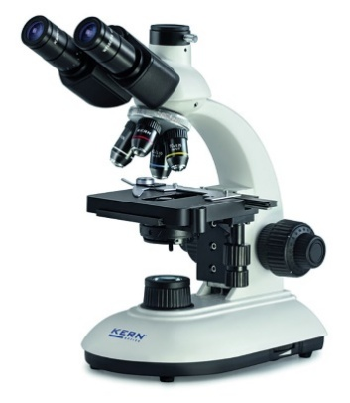
- Observe that a flat platform, or stage as it is called, extends between the upper lens system and the lower set of devices for providing light. The stage has a hole in the center that permits light from below to pass upward into the lenses above. The object to be viewed is positioned on the stage over this opening so that it is brightly illuminated from below. Note the adjustment knobs at the side of the stage, which are used to move the slide in vertical and horizontal directions on the stage. This type of stage is referred to as a mechanical stage.
- A built-in illuminator at the base is the source of light. Light is directed upward through the abbe condenser. The condenser contains lenses that collect and concentrate the light, directing it upward through any object on the stage. It also has a shutter or iris diaphragm which can be used to adjust the amount of light admitted. A lever is provided on the condenser for operating the diaphragm.
- The condenser can be lowered or raised by an adjustment knob. Lowering the condenser decreases the amount of light that reaches the object. This is usually a disadvantage in microbiological work. It is best to keep the condenser fully raised and to adjust light intensity with the iris diaphragm.
- Above the stage, attached to the arm, a tube holds the magnifying lenses through which the object is viewed. The lower end of the tube is fitted with a rotating nosepiece holding three or four objective lenses. As the nosepiece is rotated any one of the objectives can be brought into position above the stage opening. The upper end of the tube holds the ocular lens, or eyepiece (a monocular scope has one; a binocular scope permits viewing with both eyes through two oculars).

Care and Handling of the Microscope

- Always use both hands to carry the microscope, one holding the arm, other under the base.
- Before each use, examine the microscope carefully and report any unusual condition or damage.
- Keep the oculars, objectives, and condenser lens clean. Use dry lens paper only.
- At the end of each laboratory period in which the microscope is used, remove the slide from the stage, wipe away the oil on the oil-immersion objective, and place the low-power objective in vertical position.
- Replace the dust cover, if available, and return the microscope to its box.

