Experiment 10
Data handling and interpretation associated with heat sterilization processes

The objective of this experiment is to familiarize you with data handling and interpretation associated with heat sterilization processes.

Bio-indicator
The general pattern of resistance of microorganisms to biocidal sterilization processes is independent of the type of agent employed (heat, radiation or gas), with vegetative forms of bacteria and fungi, along with the larger viruses, showing a greater sensitivity to sterilization processes than small viruses and bacterial or fungal spores. The choice of suitable reference organisms for testing the efficiency of sterilization processes is therefore made from the most durable bacterial spores; these are usually represented by Bacillus stearothermophilus for moist heat, certain strains of B.subtilis for dry heat and gaseous sterilization, and B.pumilus for ionizing radiation.

Survivor curves

When microorganisms are exposed to a killing process, they lose their viability in an exponential pattern independent to the initial count.
Survivor curve: plots the logarithmic of the fraction of survivors against the exposure time or dose.
Typical curves have a linear portion which continuous (plot A) or modified by an initial shoulder (plot B) or by a reduced rate of kill at low survivor levels (plot C)
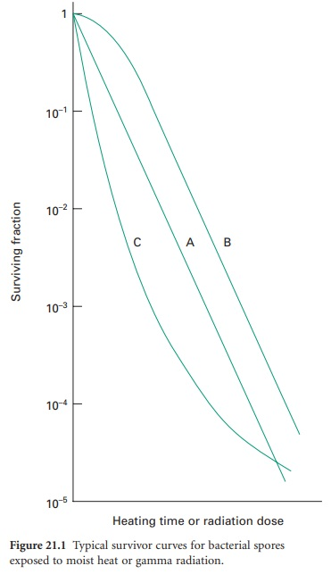
Sterility assurance level (SAL)

The term ‘sterile’, in a microbiological context, means no surviving organisms whatsoever. Thus, there are no degrees of sterility; an item is either sterile or it is not, and so there are no levels of contamination which may be considered negligible or insignificant and therefore acceptable. From the survivor curves presented, it can be seen that the elimination of viable microorganisms from a product is a time-dependent process, and will be influenced by the rate and duration of biocidal action and the initial microbial contamination level. It is also evident from survival curve A that true sterility, represented by zero survivors, can only be achieved after an infinite exposure period or radiation dose. Clearly, then, it is illogical to claim, or expect, that a sterilization procedure will guarantee sterility.

Thus, the likelihood of a product being produced free of microorganisms is best expressed in terms of the probability of an organism surviving the treatment process, a possibility not entertained in the absolute term ‘sterile’. From this approach has arisen the concept of sterility assurance or a microbial safety index which gives a numerical value to the probability of a single surviving organism remaining to contaminate a processed product
For pharmaceutical products, the most frequently applied standard is that the probability, post-sterilization, of a non-sterile unit is no more than 1 in 1 million units processed (i.e. ≤ 10⁻ ⁶).

SAL also describes the killing efficacy of a sterilization process. So we can say that a very effective sterilization process has a very low SAL.

Expressions of Resistance

- D-value.
- Z-value.
- F-value.

D-value

For heat treatments, D-value is defined as the time taken at a fixed temperature required to achieve a 90% reduction in viable cells (1 log cycle reduction in survivors).

The calculation of the D-value assumes a linear type A survivor curve, and must be corrected to allow for any deviation from linearity with type B or C curves.

High D-value reflects an increase in the resistance of the microorganism to the killing process.

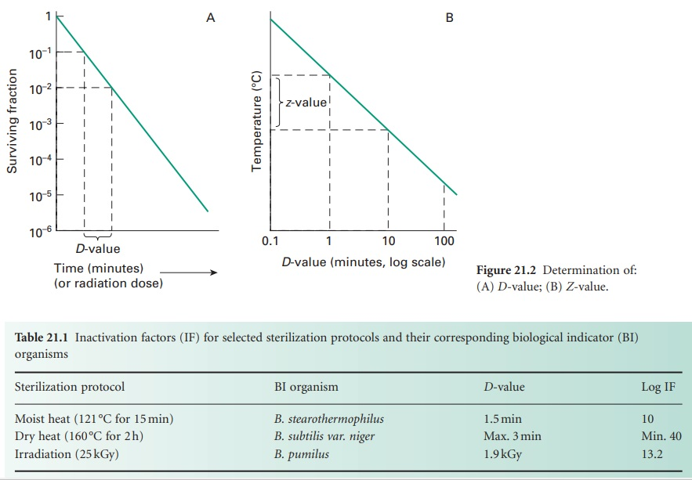

z-value

For heat treatment, a D-value only refers to the resistance of a microorganism at a particular temperature.
In order to assess the influence of temperature changes on thermal resistance, a relationship between temperature and log D-value can be developed, leading to the expression of a Z-value, which represents the increase in temperature needed to reduce the D-value of an organism by 90% (i.e. 1 log cycle reduction).

High Z-value reflects an increase in the resistance of the microorganism to heat.

For bacterial spores used as biological indicators for moist heat (B. stearothermophilus) sterilization processes, mean Z-values are given as 10 °C.

F-value

In any heat sterilization process, the articles to be treated must first be raised to sterilization temperature and this involves a heating-up stage. In the traditional approach, timing for the process (the holding time) then begins. It has been recognized, however, that during both the heating-up and cooling-down stages of a sterilization cycle, the product is held at an elevated temperature and these stages may thus contribute to the overall biocidal potential of the process.

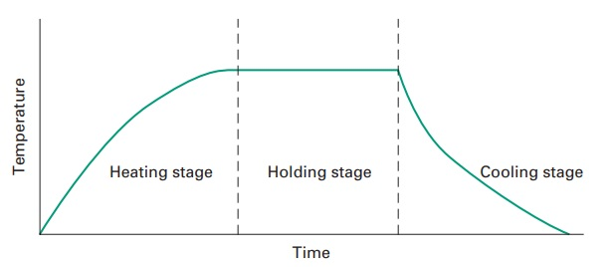
Typical temperature profile of a heat sterilization process

During the heating, sterilizing and cooling stages of a moist heat (steam) sterilization cycle the temperature–time combinations can be converted to the equivalent time at 121 °C.

Using this approach, the overall lethality of any process can be deduced and is defined as the F-value; this expresses heat treatment at any temperature as equal to that of a certain number of minutes at 121 °C.

In other words, if a moist heat sterilization process has an F-value of x, then it has the same lethal effect on a given organism as heating at 121 °C for x minutes, irrespective of the actual temperature employed or of any fluctuations in the heating process due to heating and cooling stages.

The F-value of a process will vary according to the moist heat resistance of the reference organism.

When the reference spore is that of B. stearothermophilus with a Z-value of 10 °C, then the F-value is known as the F ₀-value.

A relationship between F-and D-values, leading to an assessment of the probable number of survivors in a load following heat treatment, can be established from the following equation:

$$F=D(\log{N_{0}}-\log{N)}$$

Then

$$\log{N}=\log{N_{0}}-\left(\frac{F}{D}\right)$$
Where D is the D-value at 121 °C, and N ₀ and N represent, respectively, the initial and final number of viable cells per unit volume.
The F-concept enables a sterilization process to be individually developed for a particular product. This means that adequate sterility assurance can be achieved in autoclaving cycles in which the traditional pharmacopoeial recommendation of 15 minutes at 121 °C is not achieved.

The holding time may be reduced below 15 minutes if there is a substantial killing effect during the heating and cooling phases, and an adequate cycle can be achieved even if the ‘target’ temperature of 121 °C is not reached.

Thus, F-values offer alternative sterilizing cycles and a mechanism by which over-processing of marginally thermos-labile products can be reduced without compromising sterility assurance.

F ₀ values calculated by using the following equation:

$$F_{O}= {10}^{\frac{T-121}{Z}}× ∆t$$

where Δ t is the time interval between temperature measurements, T is the product temperature at time t, and Z is (assumed to be) 10 °C.

Example:
If we assume sterilization lasts 15 minutes, constantly at 111°C, we instead obtain:
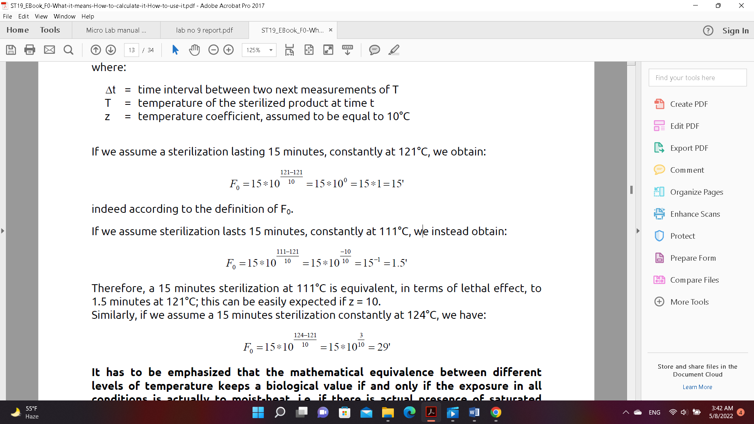
Therefore, a 15 minutes’ sterilization at 111°C is equivalent, in terms of lethal effect, to
1.5 minutes at 121°C; this can be easily expected if z = 10.

Similarly, if we assume a 15 minutes’ sterilization constantly at 124°C, we have:

If the heating process involve multi stages (heating, holding and cooling) F ₀ total will equal to:

F ₀= F ₀ heating + F ₀ holding + F ₀ cooling

