Experiment 2
Preparation of culture media under aseptic conditions.
Quality assurance –microbial monitoring of environment

- Objective:
The aim of this experiment is to:
- Prepare culture media under aseptic conditions
- Conduct quality assurance tests-microbial monitoring of environment

- Introduction:

Source of microbial contamination:
- Personal contamination
The population of microorganisms that inhabit the skin, mucous membranes or any other anatomical site of healthy normal persons is called normal microbial flora
Normal flora is classified into two types:
1. Resident flora
Consists of relatively fixed types of organisms which are regularly present in a particular area and when disturbed it reestablishes itself like Esch. coli is a normal inhabitant of the intestine.
The microbes of the normal resident flora are harmless and may be beneficial in their normal location in the host and in the absence of coincident abnormalities. They may produce disease if introduced into foreign locations in large numbers and if predisposing factors are present.
2. Transient flora
Consists of nonpathogenic or potentially pathogenic microorganisms that inhabit the skin or mucous membranes for hours, days, or weeks; it is derived from the environment, does not produce disease, and does not establish itself permanently on the surface. Members of the transient flora are generally of little significance as long as the normal resident flora remains intact. However, if the resident flora is disturbed, transient microorganisms may colonize, proliferate, and produce disease.
**During lab work normal flora can cause contamination if not controlled:
- contamination from hands
Your fingers are NOT clean. The surface of your skin is home to thousands of bacteria. These bacteria are essential for our health. However, they will easily contaminate media, plates and glassware in the lab. Therefore, you need to be careful not to touch pipette tips, the insides of the plate lids. Or any other surfaces which are sterile.
- contamination from hair
- contamination from respiratory system
- Contamination from air
- Contamination from water
- Contamination from surfaces
Preparation of Culture Media under Aseptic Conditions

To grow bacteria, we should provide them with suitable environmental conditions and suitable media to allow them to divide by binary fission to increase in cell number (not in cell size).
a. Environmental conditions:
- Temperature: Most microorganisms live within restricted ranges of temperature with a range of tolerance (minimum and maximum tolerated temperature). The minimum growth temperature is the lowest temperature at which a species will grow, the optimum growth temperature is the temperature at which it grows best, and the maximum growth temperature is the highest temperature at which growth is possible.

- pH: Most bacteria prefer neutral pH (6.5-7.5). Molds and yeast grow in wider pH range while it prefers a pH between 5 and 6.

- Osmotic Pressure: Cells have about 80 to 90% water of their structure, and normally the salt concentration of microbial cytoplasm is about 1%.
What is the effect of presence of microbes in hypertonic or hypotonic solution?

- Other factors: Like light and time.

b. Bacterial culture media
The mixture (in which the nutrients are supplied) is referred to as growth medium or culture medium.
A growth medium or culture medium is a liquid or gel designed to support the growth of microorganisms or cells, or small plants
Generally, the growth medium contains:
- Moisture (water)
- An energy source, for example: glucose, amino acids, nitrite and nitrate
- Nutritionally suitable sources of carbons, nitrogen, sulfur and oxygen
- Organic growth factors, for example: amino acids.

Media must be prepared in such a way that it is sterile prior to being inoculated with a bacterial sample, so that when a particular type of bacteria is cultured (cultivated) on that medium, it is the only type of bacteria present.

Autoclave: It is a sterilization procedure performed by means of temperature and pressure. It is used only for the sterilization of heat stable media and equipment. An autoclave is basically a huge steam cocker. Steam enters into a jacket surrounding a chamber. The pressure will go up over 15 pounds per square inch (psi); at this point the timer begins to count down usually for 15 minutes. The high pressure in a closed container allows the temperature to go around 121°C (249 °F). Therefore, the parameters for sterilization with an autoclave are 121°C at ≥15 psi for 15 minutes. Fifteen Minutes is the thermal death time for most microorganisms (except some really hardy spore-formers).

Aseptic techniques applied to prepare sterile culture media

Aseptic technique is a method designed to prevent contamination from microorganisms. It involves applying the strictest rules and utilizing what is known about infection prevention to minimize the risks that you'll experience an infection

Aseptic techniques that should be followed to prepare a sterile culture media:
- Doors and windows are kept closed
- Hand hygiene “as described previously”
- Decontaminate the surface of your bench at least one time using 70% alcohol
- Turn on the Bunsen burner and make sure that the flame is no more than four inches high and that the blue inner cone more than two inches high. (Figure below D and E)
- Agar plates are held in a manner that minimizes the exposure of the surface to the environment. The Petri dish tops are lifted with the left hand and replaced immediately as the plate is poured
- When removing lids from tubes, lids are held in the hand and not placed on the countertop during the transfer of materials from one tube to another.
- Sterilize all needed glassware in autoclave prior to use.

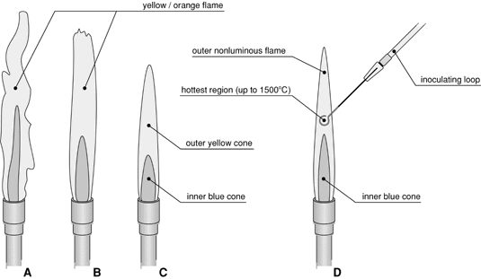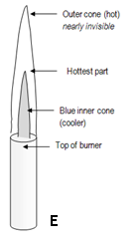

Classification of culture media:
A. Classification based on consistency
- Liquid (Broth) medium: these media contain specific amounts of nutrients but don’t have trace of gelling agents such as gelatin or agar. Broth medium serves various purposes such as propagation of large number of organisms, fermentation studies, and various other tests.
- Solid medium (Agar): is media containing agar (at a concentration of 1.5-2.0%) or some other, agar is mostly inert solidifying agent. Solid medium has physical structure, and this allows bacteria to grow in physically informative or useful ways (e.g. as colonies or in streaks). solid medium is useful for isolating bacteria or for determining the characteristics of colonies.
- Semisolid media: they are prepared with agar at concentrations of 0.5% or less. They have soft custard-like consistency and are useful for the cultivation of microaerophilic bacteria or for determination of bacterial motility.

Agar:
The discovery of agar (a polysaccharide derived from red algae) has revolutionized the study of microbiology because of its distinctive properties:
- Agar at a concentration of about 1 – 1.5 %(w/v) will provide a firm gel that cannot be liquefied by the enzymes normally produced during bacterial growth.
- Agar is semi-translucent
- An agarose medium is porous
- Fluid agar solutions set (solidify) at approximately 40°C, but do not reliquefy on heating until the temperature is more than 90°C.

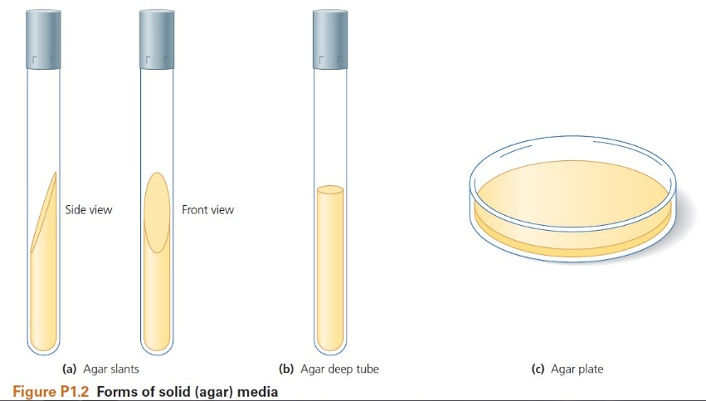
Thus, agar forms a firm gel at 37°C which is the normal incubation temperature for many pathogenic microorganisms. And when used as a liquid at 45°C is at a sufficiently low temperature to avoid killing microorganisms (this property is important in pour plate counting method).
Forms of solidified agar:

A. Slant (test tube):
- 1/3 full
- Solidified in a slant position

B. Deep (test tube):
- 1/3 – 1/2 full
- Solidified in an upright position
- For reduced O2 environment
- Or for observation of in-media growth
- Plates (Petri-dish)

Practical part

Part 1: Preparation of Culture Media under Aseptic Conditions

Preparation and preservation of media
Most culture media are sterilized by autoclaving. Certain media that contain heat labile components like glucose, antibiotics, urea, serum and blood are not autoclaved only they are filtered and may be added separately after the medium is autoclaved.
Prepared media may be held at 4-5 °C in the refrigerator for 1 to 2 weeks. Certain liquid media in screw capped bottles or tubes or cotton plugged can be held at room temperature for weeks.

Pouring Solid media:
Sterilized agar should be allowed to cool to about 50 °C (the agar should be warm and molten, but not too hot to handle in its flask). Pour agar solution into plate.

- Pouring procedure should be performed in an aseptic manner to prevent contamination: speech is prohibited, and Bunsen burner should be ON
- Open the cover of Petri-dish with one hand and while still holding the cover over the Petri-dish, pour approximately 20 mL of agar solution into the dish. Cover the dish.
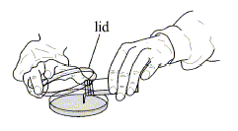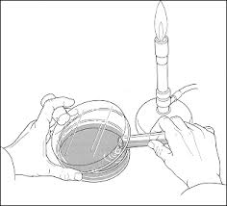
- Flame the surface of agar solution to remove any bubbles that formed during pouring and to make the surface smooth. Cover the dish

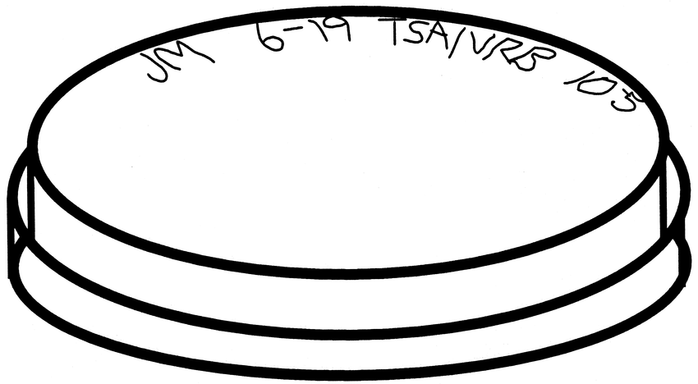
- When the plates are cool (agar solidified), invert them to prevent condensing moisture from accumulating on the agar surface. If it happened the medium could be destroyed.

- To test the sterility of broth and agar plates. Place the inverted agar plates and tubes of sterilized nutrient broth in the incubator at 37 °C. They should be incubated for at least 24 hours to ensure they are sterile (free of contaminating bacteria) before using them.
Part 2: Quality assurance- Microbial monitoring of environment

- Personal contamination: Contamination from hands
- Divide the nutrient agar plate into 4 sections and label 1 through 4.
- Section 1 is your negative control. Don’t touch it.
- Take fingerprint (3 fingers) firmly from unwashed fingers on section 2
- Wash your hand thoroughly with detergent and water
- Allow the hands to dry in the air and take fingerprints firmly from the same fingers in the section 3 of the plate
- Rub disinfectant into the hands, leave hands to dry in air and again take fingerprints (the same fingers) on the section 4 of the plate.
- Incubate the plate inverted for 24 hours at 37 ºC
- Draw the general appearance of the plate and describe a few types of colonies observed

- Contamination from air
- Expose the agar plate to air by placing it over the bench for 2 hours
- Expose another agar plate to the air by placing it into the laminar air flow for 2 hours
- Replace the lid and incubate the plate inverted at 37 ºC for 24 hours
- Examine your plates and describe some of the colonies observed

- Contamination from water
- Divide an agar plate into two sections and label as tap water and sterile water
- Soak a sterile swab with tap water and then streak on the surface of the first section of the agar plate.
- Soak a sterile swab with sterile water and then streak on the surface of the second section of the agar plate
- Incubate the plate for 24 hours at 37 ºC
- Describe the general appearance of the agar plate.

- Contamination from surfaces
- Divide the nutrient agar plate into 3 sections and label 1 through 3.
- Use sterile cotton swab to swab a bench surface before cleaning with disinfectant then streak on the surface of the first section of petri dish
- Clean your bench using disinfectant and repeat step 2 with a new sterile cotton swab on the second section of the agar plate
- Use sterile cotton swab to swab an area from the environment such as a doorknob, floor or water knob, then streak on the surface of the third section of petri dish
- label correctly each section with its nominated sample.
- Incubate the plate inverted for 24 hours at 37 ºC
- Draw the general appearance of the plate and describe a few types of colonies observed

