Experiment 4
Bacterial Identification
Simple staining, Gram staining and differential medium

- Objectives:
- Bacterial identification using Gram staining.
- Bacterial differentiation using MacConkey agar plate.

- Introduction:
- Bacteria have nearly the same refractive index as water, so they are opaque or nearly invisible to the naked eye when observed under a microscope. To make the cells and their internal structures more visible under the light we need to stain the cells.
- Simple Staining
- Aim:
To compare the morphological shapes and arrangements of bacterial cells
- Principle:
One of the traditional staining techniques is simple staining of bacteria. This method uses only one stain. To make the microorganisms visible to the naked eye.
Direct staining employs basic dyes such as methylene blue, safranin, crystal violet, malachite green, and others. The basic stains have different exposure times to penetrate and stain the bacterial cell.
In general, the procedure consists of three sequential steps: smear preparation, heat fixing, and bacteria staining.
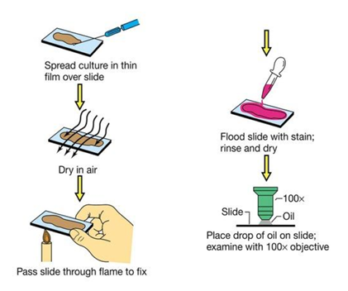
In preparing for staining, a small sample of microorganisms is placed on a slide and permitted to air dry. The smear is heat fixed by quickly passing it over a flame. Heat fixing kills the organisms, makes them adhere to the slide and prevents the sample from being lost during staining procedure and permits them to accept the stain.
Microscope, various staining methods are used.

- Differential staining:
Differential staining requires the use of at least 3 chemical reagents that are applied sequentially to a heat fixed smear.
The primary stain is to impart its color to all cells. In order to establish a color contrast, the second reagent used is the decolorizing agent. Based on the chemical composition of cellular components the decolorizing agent may or may not remove the primary stain from the entire cell or from any cell structure. The final reagent is the counter stain.
Following discoloration, if the primary stain is not washed out, the counter stain cannot be absorbed and neither the cell nor its components will retain the color of the primary stain.
If the primary stain is removed, the decolorized cellular components will accept and assume the contrasting color of the counter stain. In this way, cell type or their structure can be distinguished from each other. On the basis of the stain that is retained the most important differential stain used in bacteriology is the Gram stain.
- Gram-Staining
The Gram staining method is one of the most important staining techniques in microbiology. It is almost always the first test performed for the identification and classification of bacteria into two groups designated Gram-positive and Gram-negative according to their reaction to a staining procedure developed in 1884 by Christian Gram.
- Aim:
- To differentiate two principal groups of bacteria.
Gram staining is a common technique used to differentiate two large groups of bacteria based on their different cell wall constituents. The Gram stain procedure distinguishes between Gram-positive and Gram-negative groups by coloring these cells red or violet.
Gram staining is based on the ability of bacteria cell wall to retain crystal violet dye during solvent treatment. Gram-positive bacteria stain violet due to the presence of a thick layer of peptidoglycan in their cell walls, which retains the crystal violet inside these cells when stained with.
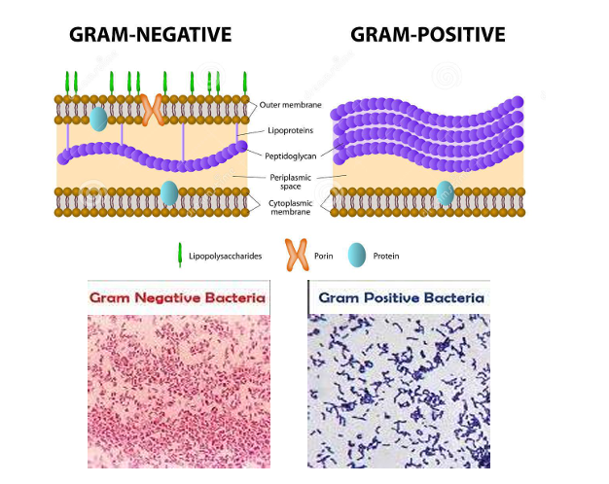
Alternatively, Gram negative bacteria stain red, which is attributed to a thinner peptidoglycan wall, which does not retain crystal violet during the decolorizing process.
- Differential medium:
MacConkey agar is a selective and differential culture medium that is used for the isolation of Gram-negative enteric bacteria and the differentiation of lactose fermenting from lactose non-fermenting Gram-negative bacteria.
It is one of the most commonly used media in pharmaceutical industry, food industry, drinking water control & clinical laboratories.
- Selective: it encourages the growth of some microorganisms but suppresses the growth of others.
- Differential: it has a constituent that causes an observable change such as color change or pH change in the medium when a particular biochemical reaction occurs.
It is a complex medium that contains peptone, bile salts, crystal violet, lactose and Neutral red pH indicator. Bile salts and crystal violet inhibit the growth of most Gram-positive organisms. Lactose can be fermented by some microorganisms (Gram negative organisms) producing acidic metabolites which lower the medium pH. The pH indicator turns pink-red at a pH below 6.8 and is colorless at any pH greater than 6.8. Non-fermenters will produce colorless colonies.
Enteric bacteria (those that live in the intestines such as Escherichia coli, Enterobacter and Klebsiella) are Gram-negative lactose fermenters and hence they grow in red or pink colonies when using MacConkey agar. Non-lactose fermenting Gram-negative bacteria such as, Proteus species, Salmonella, Pseudomonas aeruginosa and Shigella cannot utilize lactose in the medium and will use peptone instead. This results in the formation of ammonia, which raises the pH of the agar, and leads to the formation of white or colorless colonies in the plate.
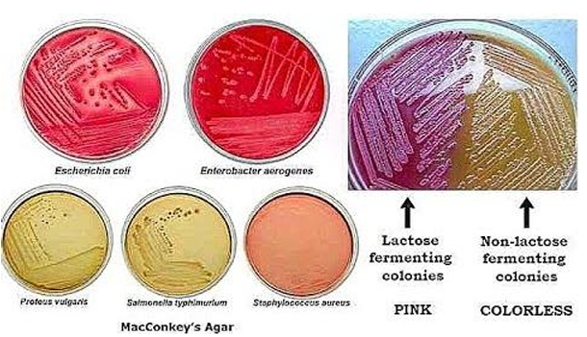
- Bacterial morphology and arrangement:
There are three basic shapes of bacteria:
- Coccus (pleural: Cocci): Spherical bacteria that may occur in:
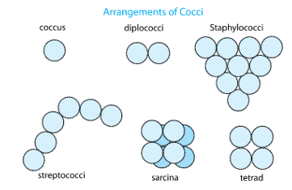
- Single (coccus)
- pairs (diplococci)
- Groups of four (tetracocci)
- Grape like clusters (staphylococci),
- Chains (streptococci)
- Cubical arrangements of eight or more (sarcina).

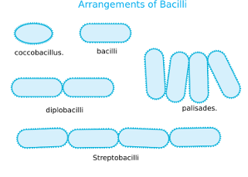
- Bacillus (pleural: Bacilli): Rod- shaped bacteria that:
  - Generally, occur singly (bacillus).
  - Also found in pairs (diplobacilli).
  - In chains (streptobacilli).

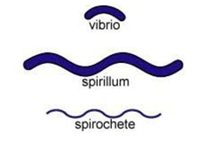
- Spiral shape: come in one of three forms
- Vibro: curved or comma- shaped
- Spirillum: thick, rigid spiral
- Spirochete species: a thin, flexible spiral

Practical part
➢ Part 1: Smear preparation and heat fixing
1. Obtain a clean microscope slide.
2. Label the frosted edge appropriately with the sample identification.
3. Transfer specimen or culture to the center of the slide. Culture from solid media: Using a sterile pipette, add one drop of sterile saline or sterile water to the center of the microscope slide. Aseptically pick a small amount of an isolated colony with a loop and gently mix into the drop of sterile saline or water using circular motions. Mix evenly to make a thin smear.
4. Allow the smear to air dry completely.
5. Fix the smear to the slide using heat fixation
6. Allow the slide to cool to room temperature or air dry.
➢ Part 2: Gram staining
To a bacterial smear the following chemicals are applied to make a Gram-stain:
1. Gram’s Crystal Violet Stain (primary stain)
The smear is flooded with Crystal Violet for 60 seconds. Crystal violet is a purple chemical that sticks to the peptidoglycan layer of the bacterial cell wall. After 60 seconds, crystal violet is rinsed off using distilled water.
Explanation: All cells are purple after this step. Stopping here would be a simple stain.
2. Iodine (mordant)
Flood the smear with iodine for 60 seconds then wash immediately with distilled water. This causes crystal violet to stick to peptidoglycan like mortar causes bricks to stick together.
Explanation: Gram’s iodine forms a complex with crystal violet. All cells are purple after this step.
3. 95% Ethanol/ acetone (decolorizing)
95% ethanol is added drop by drop for 5-10 seconds then washed immediately with water. The Acetone/Alcohol washes crystal violet out of the Gram-negative cell wall. The
Gram-positive cell wall retains crystal violet as long as the acetone/alcohol wash lasts not more than a few seconds. The acetone/alcohol wash is the differential step in the Gram-stain process.
Explanation: Gram-positive cells retain crystal violet and remain purple. Gram-negative cells lose crystal violet and are now colorless. Water rinse stops the decolorization process.
4. Safranin Stain (secondary or counter stain)
The smear is flooded with Safranin for 60 seconds then wash immediately with water.
Safranin is a stuck to cytoplasmic component of the cell. All cells become stained with safranin.
Explanation: Safranin is a pink/red dye. After this step Gram-positive cells remain purple; Gram-negative cells are now pink/red
5. Drying the Slide
Dry the smear by blotting a filter paper. Then add one drop of oil on the smear to observe the result under the light microscope using oil-immersion objective lens (100x). Note the Gram stain reaction and cell shape.
➢ Part 3: Use of Microscope
• General points:
Treat the instrument with care, clean the lenses and eyepieces with lens tissue, and remove any water or oil with lens tissue before leaving the laboratory.

• To examine your slide:
1. Focus on a specimen with the 40X lens
2. Close the field diaphragm down completely
3. Using the condenser height adjustment focus on the image of the field diaphragm.
4. Open the field diaphragm until it just disappears from the field of view.
5. Remove the right eyepiece and adjust the condenser aperture until you can just see the edge of it down the eyepiece.
6. Switch the 100x objective lens and with oil on the specimen repeat the process. The microscope is now ready for use.
7. Repeat these steps every time you use your microscope.
• Interpretation of results:
1. Color: either Gram-positive or Gram-negative
2. Shape and arrangement
3. Older cells might have been dead or with damaged cell wall; giving false results.
Gram-positive cells would have mixed results (purple and red) because not all cells might be damaged.
4. Excessive decolorization (> 10 seconds) would affect Gram-positive cells.
5. No proper decolorization (< 5 seconds) would affect Gram-negative cells.
➢ Part 4: Streaking a MacConkey agar plate
1. Take MacConkey agar plate & on the base draw lines to divide it into three sections, write on the sections negative control (NG), G+ve and G-ve.
2. Don’t touch the negative control section.
3. At the G-ve section streak the plate with E. coli.
4. At the G+ve section streak the plate with the Gram-positive bacteria provided (Staphylococcus aureus).
5. Incubate the plate inverted at 37°C.

