Experiment 6
Testing of Disinfectants

Objectives:
- To identify the key factors that influence the effectiveness of disinfectants, such as concentration and contact time
- To perform and evaluate qualitative and quantitative suspension tests to assess the bactericidal efficacy of selected disinfectants.

Introduction
Disinfection is the process of elimination of most pathogenic microorganisms (excluding bacterial spores) on inanimate objects. Disinfection can be achieved by physical or chemical methods. Chemicals used in disinfection are called disinfectants. Different disinfectants have different target ranges, not all disinfectants can kill all microorganisms. Some methods of disinfection such as filtration do not kill bacteria, they separate them out. Sterilization is an absolute condition while disinfection is not

Disinfectants are those chemicals that destroy pathogenic bacteria from inanimate surfaces. Some chemicals have very narrow spectrum of activity and some have very wide. Those chemicals that can sterilize are called chemisterilants. Those chemicals that can be safely applied over skin and mucus membranes are called antiseptics.

An ideal antiseptic or disinfectant should have the following properties:
- Should have a wide spectrum of activity
- Should be able to destroy microbes within practical period of time
- Should be active in the presence of organic matter
- Should make effective contact and be wettable
- Should be active in any pH
- Should be stable and have a long shelf life
- Should have high penetrating power
- Should be non-toxic, non-allergenic, non-irritant or non-corrosive
- Should not have bad odor
- Should not leave non-volatile residue or stain
- Efficacy should not be lost on reasonable dilution
- Should not be expensive and must be available easily

Such an ideal disinfectant is not yet available. The level of disinfection achieved depends on contact time, temperature, type and concentration of the active ingredient, the presence of organic matter, the type and quantum of microbial load.

Classification of disinfectants:
- Based on consistency
- Liquid (E.g., Alcohols, Phenols)
- Gaseous (Formaldehyde vapor, Ethylene oxide)

- Based on the spectrum of activity
- High level
- Intermediate level
- Low level
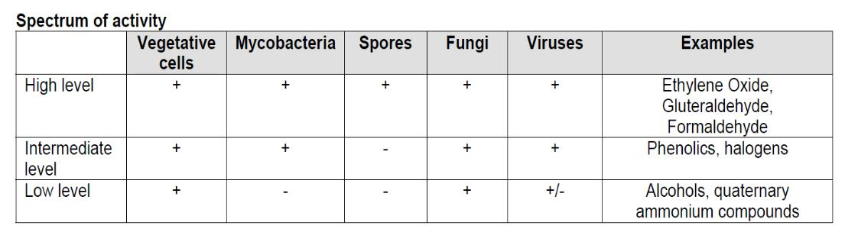
3. Based on the mechanism of action
- Action on membrane (E.g., Alcohol, detergent)
- Denaturation of cellular proteins (E.g., Alcohol, Phenol)
- Oxidation of essential sulfhydryl groups of enzymes (E.g., H2O2, Halogens)
- Alkylation of amino-, carboxyl- and hydroxyl group (E.g., Ethylene Oxide, Formaldehyde)
- Damage to nucleic acids (Ethylene Oxide, Formaldehyde)

Factors Influencing the Action of Disinfectants
- Type of disinfectant
- Concentration of disinfectant
- Contact time: the longer the contact time, the greater the kill
- Temperature
- Type of organisms
- Concentration of organisms
- Nature of suspending liquid

Evaluating Disinfectant Activity
Suspension tests:
In these tests, a sample of the bacterial culture is suspended into the disinfectant solution and after exposure it is verified by subculture whether this inoculum is killed or not. Suspension tests are preferred to other tests as the bacteria are uniformly exposed to the disinfectant.
There are different kinds of suspension tests:
- Test for the determination of the phenol coefficient (Rideal and Walker).
- The qualitative suspension tests.
- The quantitative suspension tests.

- Determination of phenol coefficient:
Phenol coefficient (PC or PE) of a disinfectant is calculated by dividing the dilution of test disinfectant by the dilution of phenol that disinfects under predetermined conditions.
Rideal Walker method: the phenolic disinfectant is diluted from 1:400 to 1:800 and phenol is diluted from 1:95 to 1:115. Their bactericidal activity is determined against Salmonella typhi suspension. Subcultures are performed from both the test and phenol at intervals of 2.5, 5, 7.5 and 10 minutes. The plates are incubated for 48-72 hours at 37°C. Then PC is calculated.
PC or PE = (highest DF of disinfectant required to eliminate bacteria within 7.5 minutes but not in 5 minutes) / (highest DF of phenol required to eliminate bacteria within 7.5 minutes but not in 5 minutes).
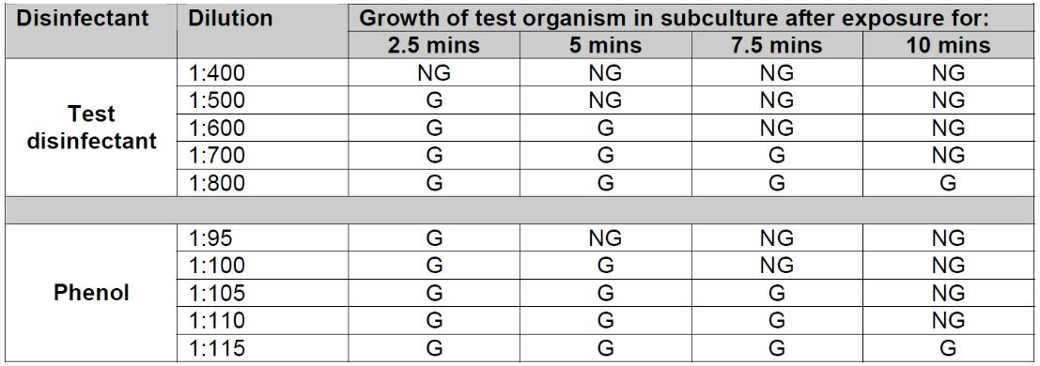

Example:
To calculate phenol coefficient of the tested disinfectant in the above table. After 7.5 minutes, the test organism was killed by the test disinfectant at a dilution of 1:600. In the same period the test organism was killed by phenol at a dilution of 1:100.
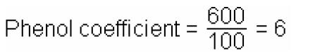
This result indicates that the test disinfectant can be diluted six times as much as phenol and still possess equivalent killing power for the test organism.

**Test interpretation:
- If a phenol coefficient is no greater than 1 indicates that this agent is equal to or less effective than phenol.

- If a phenol coefficient is greater than 1 indicates that this agent is more effective than phenol.

Disadvantages of the Rideal-Walker test are:
- No organic matter is included
- The microorganism Salmonella typhi may not be appropriate
- The time allowed for disinfection is short also the presence of time skips
- It should be used to evaluate phenolic type disinfectants only.

- The qualitative suspension tests
This was done in a qualitative way. A loopful of bacterial suspension was brought into contact with the disinfectant and again a loopful of this mixture was cultured for surviving organisms. Results were expressed as ‘growth (+)’ or ‘no growth (-)’
- The Quantitative Suspension Test:
In quantitative methods, the number of surviving organisms is counted and compared to the original inoculum size. By subtracting the logarithm of the former from the logarithm of the latter, the decimal log reduction or microbicidal effect (ME) or Germicidal Effect (GE) is obtained. An ME of 1 equal to a killing of 90% of the initial number of bacteria, an ME of 2 means 99% killed. A generally accepted requirement is an ME that equals or is greater than 5: at least 99.999% of the germs are killed. Even though these tests are generally well standardized, their approach is less practical.

The Microbicidal Effect (ME):
The Decimal Reduction Rate or the Microbicidal Effect (ME) can be calculated by using the following formula:
ME = Log NC – Log ND
NC: Number of colony forming units (CFU) developed in the control series, in which the disinfectant is replaced by sterile normal saline.
ND: Number of colony forming units (CFU) developed in the disinfectant series, after exposing the bacterial cells to the disinfectant.

Note:
Counts are selected to be from 25 – 250 colonies. For results having more than one accepted count; the number closer to 250 (in control series), and the number closer to 25 (in disinfectant series) are used in the ME equation.

Do not forget to multiply the selected number of colonies by the corresponding dilution factor.

Example:
Calculate the ME for 70% ethanol which was used during a quantitative suspension test, knowing that the subculture step was performed using surface inoculation technique:
Dilution Factor |  | # of CFUs
Dilution Factor | Control Series |  | Disinfectant Series
10¹ | TNTC |  | TNTC
10² | TNTC |  | 95
10³ | 310 |  | 33
10⁴ | 240 |  | 28
10⁵ | 120 |  | 0

ME = Log NC – Log ND

ME = Log (240 * 10⁴) – Log (28 * 10⁴)
ME =2.38-1.48 = 0.9

Practical Part

- (Qualitative Suspension Test)
This test is followed only by the DGHM guidelines
Procedure (under aseptic conditions):
- 0.1 mL of a bacterial suspension of 1*10⁸ CFU/mL is exposed to 10 mL of disinfectant with various dilutions (95%, 70% or 35% Ethanol).
- After certain cumulative exposure times (2, 4, 8, 15 and 30 minutes), take a 0.001 mL sample (using inoculating loop: flamed and cooled) from the reaction mixture and add it to 5 mL nutrient broth. This step is both neutralization and subculture.
- Incubate test tubes overnight at 37°C and examine each test tube whether it is turbid (+) or clear (-).

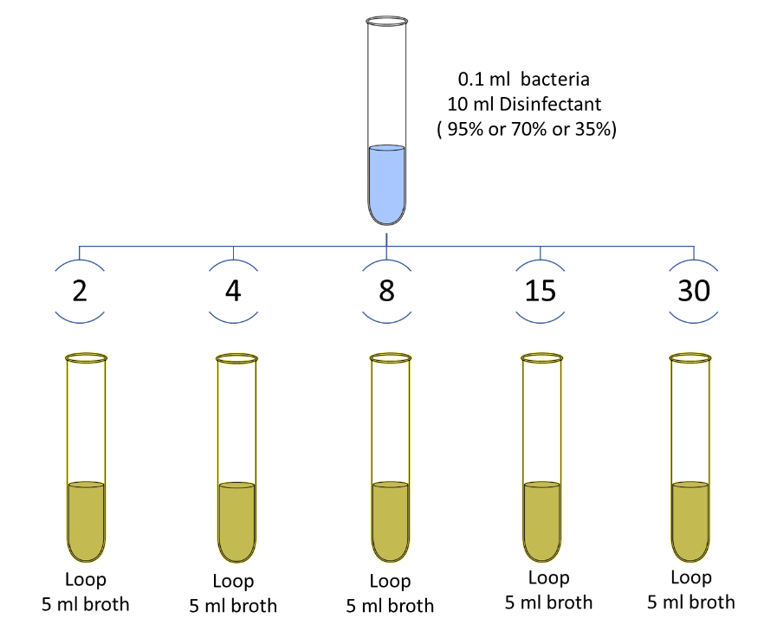

- (Quantitative Suspension Test):
Procedure: (under aseptic conditions)
- Expose 1 mL of bacterial suspension to 10 mL of disinfectant (70% ethanol). Add another 1 mL to the control (sterile NS or sterile DS)

- After 5 sec, 30 sec or 60 sec, neutralize 1 mL of reaction mixture using 9 mL nutrient broth.

- Serially dilute the neutralized sample 4 times (by 10x dilution factors).

- Subculture the neutralized sample and the followed 4 dilutions on agar plates for counting, using surface inoculation technique.

