Experiment 7

Qualitative methods used for the evaluation of bacteriostatic activity of different antimicrobial agents
- Objectives:
- Evaluate the different methods of antimicrobial susceptibility testing.
- Specifically differentiate between the qualitative methods of antimicrobial susceptibility testing.

- Introduction:
Resistance to antimicrobial agents (AMR) has resulted in morbidity and mortality from treatment failures and increased health care costs. Although defining the precise public health risk and estimating the increase in costs is not a simple undertaking, there is little doubt that emergent antibiotic resistance is a serious global problem. The results of in- vitro antibiotic susceptibility testing, guide clinicians in the appropriate selection of initial empiric regimens and drugs used for individual patients in specific situations (although sensitivity tests measure antimicrobial activity against bacteria under laboratory conditions it cannot be assumed that the results of in vitro tests will be necessarily the same in vivo). The selection of an antibiotic panel for susceptibility testing is based on the commonly observed susceptibility patterns, and is revised periodically.

Methods of Antimicrobial Susceptibility Testing:
E-Test method
Dilution and diffusion method
Quantitative
method
Agar dilution method
Dilution
method
Antimicrobial Susceptibility Test
Streak method
Kirby-Bauer method
Broth dilution method
Disc method
Strip method
Diffusion
method
Qualitative
method

Mueller Hinton Agar (MHA):
Mueller and Hinton developed Mueller Hinton Agar (MHA) it is commonly used for the routine susceptibility testing of microorganism by the diffusion technique.
Mueller Hinton Media contains Beef Extract, Acid Hydrolysate of Casein, Starch and Agar. Beef Extract and Acid Hydrolysate of Casein provide nitrogen, vitamins, carbon, amino acids, Sulphur and other essential nutrients. Starch is added to absorb any toxic metabolites produced. Starch hydrolysis yields dextrose, which serves as a source of energy. Agar is the solidifying agent.

Why MHA is used for antibiotic susceptibility testing?
- It is a non-selective, non-differential medium. This means that almost all organisms plated on here will grow.
- It contains starch. Starch is known to absorb toxins released from bacteria, so that they cannot interfere with the antibiotics. It also mediates the rate of diffusion of the antibiotics through the agar.
- It is a loose agar. This allows for better diffusion of the antibiotics than most other plates. A better diffusion leads to a truer zone of inhibition.
- MHA shows acceptable batch-to-batch reproducibility for susceptibility testing.
- MHA is low in sulfonamide, trimethoprim, and tetracycline inhibitors (i.e., concentration of inhibitors thymidine and thymine is low in MHA).
- Both the para-aminobenzoic acid (PABA) and thymine/thymidine content in Mueller Hinton Agar are reduced to a minimum, thus markedly reducing the inactivation of sulfonamides and trimethoprim when the media is used for testing the susceptibility of bacterial isolates to these antimicrobics.

- Determination of the Susceptibility of More Than One Organisms to the Bacteriostatic Agent Provided (Strip method)

Experimental:
  - Pour an agar plate and allow to set firm
  - With a sterile forceps pick a sterile paper strip from the Petri dish and dip it into the bacteriostatic solution
  - Place the soaked strip onto the surface of nutrient agar at one side
  - Transfer a loopful from each of the test organisms to be tested and streak across the agar surface starting at the margin of the strip and at right angle to it (mark each streak on the bottom of the plate to identify)
  - Incubate at 37 οC for 24 hr.
  - Measure the length of the inhibition zones for each organism

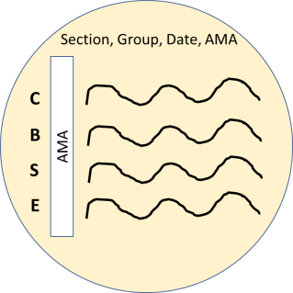
AMA: Antimicrobial agent name C: Candida albican
B: Bacillus subtilis
S: Staphylococcus aureus
E: Escherichia coli

Result after incubation:
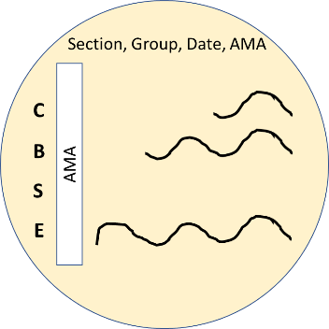
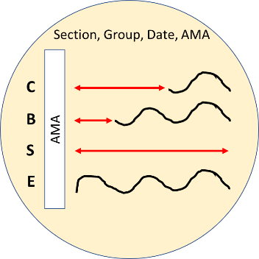
Result interpretation:
- Order according to the length of zone of inhibition:
S > C > B > E

- So, order of organism sensitivity towards the tested antimicrobial agent is:

The most sensitive microorganism is Staphylococcus aureus, then Candida albican, then Bacillus subtilis and the least sensitive (most resistant) is Escherichia coli.

- Determination of the susceptibility of a selected organism against different antibiotics (Kirby-Bauer method)

Kirby–Bauer (K-B) antimicrobial sensitivity test allows for the rapid determination of the efficacy of a drug (antibiotic) against certain type of bacteria by measuring the diameter of the zone of inhibition that resulted from diffusion of the drug from its disc into the surrounding medium.

K-B Test Standards:
- Microorganisms are isolated from infected tissues. For example:
  - Septicemia: a blood sample is obtained
  - Upper respiratory tract infections: a throat swap or a sputum sample.

The obtained bacterial suspension should be standardized by comparing it with McFarland standard # 0.5 or # 1 (according to the type of bacteria). This would be equivalent to a bacterial concentration of 1.5 * 108 cells/mL or 3 * 108 cells/mL.

- The used medium should be standardized. Mueller-Hinton Agar is used. This medium with a pH of 7.2 to 7.4 contains high percent of proteins, which will facilitate diffusion from the antibiotic disc and improve bacterial growth.

- The antibiotic disc is made from filter paper. The concentration of certain antibiotic (antibiotic amount per disc area) should be standardized to ensure consistency in results. Knowing that antibiotic concentration is a factor affecting the diffusion rate from disc into the surrounding medium.

- The incubation temperature should be standardized to be 37 °C. Since temperature is also a factor affecting rate of diffusion (proportional relationship).

- The incubation time should be standardized to be from 18 to 24 hours (overnight incubation).

Experimental:
- Prepare a bacterial lawn using MHA.
- Mark the position for the discs with a marker pen on the bottom of the plate
- With a sterile forceps (by ethanol followed by heating) pick a disc from the container.
- Place the disc onto the surface of the agar at the marked position. The discs must be distributed evenly and not too close to the plate edge.
- Use a sterile loop to help lacing the disc on the agar.

Note:
  - The minimum distance between disc centers to neighboring disc center is 24 mm, and also no closer than 10-15 mm from the edge of Petri- dish). A maximum of 6 discs may be placed on a 9-cm Petri-dish, and 12 discs on a 15-cm dish. Reduce the number of applied discs per plate if overlapping zones of inhibition are encountered.

  - A disc should not be relocated once it has come into contact with the agar surface because some of drug diffuses instantaneously. Instead, place a new disc in another location on the agar.

- Repeat steps 3 and 4 with other antibiotics disc
- Incubate the plate inverted at 37 οC for 24 h
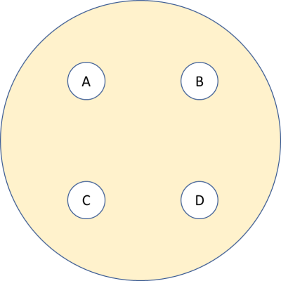

Zone of inhibition measurement and interpretation
- After 16 to 18 hours of incubation, each plate is examined. If the plate was satisfactorily prepared, the resulting zones of inhibition will be uniformly circular and there will be a confluent lawn of growth. If individual colonies are apparent, the inoculum was too light and the test must be repeated. The diameters of the zones of complete inhibition (as judged by the unaided eye) are measured, including the diameter of the disc. Zones are measured to the nearest whole millimeter, using sliding calipers or a ruler, which is held on the back of the inverted Petri plate

Note:
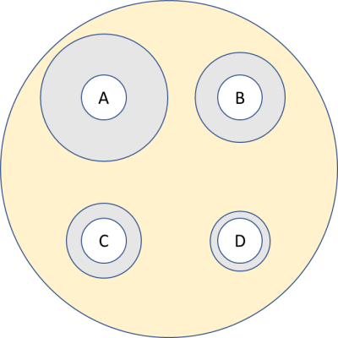
If there is NO zone at all, report it as 0, even though the disc itself is around 7 mm.

Inhibition zone diameter

- The zone margin should be taken as the area showing no obvious, visible growth that can be detected with the unaided eye. Faint growth of tiny colonies, which can be detected only with a magnifying lens at the edge of the zone of inhibited growth, is ignored. However, discrete colonies growing within a clear zone of inhibition should be subculture, re-identified, and retested.

- These zones of inhibition are then recorded for size; the diameter of the zone is proportional to the amount of anti-microbial agent, the solubility of the agent, the diffusion coefficient, and the overall effectiveness of the agent. Zones observed on the plates are then compared to standard data to determine if the isolate is truly sensitive to the antibiotic.

- The sizes of the zones of inhibition are interpreted by referring to: Zone size interpretive table for the Kirby Bauer test (CLSI table).

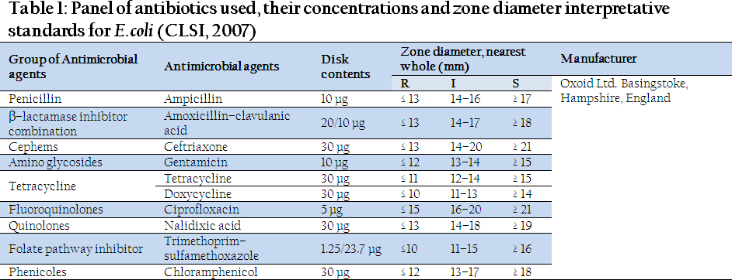

Classification of microorganisms according to susceptibility test results

- Susceptible (S): an organism is called susceptible to a drug when the infection caused by it is likely to respond to treatment with this drug, at the recommended dosage.

- Intermediate Susceptibility (I): covers two situations

  - The organism cannot be classified as either susceptible or resistant, but is interpreted as being or intermediate (I) Susceptibility to a given drug.

  - The clinical interpretation of this category is that the organisms tested may be inhibited by the antimicrobial agent provided that either:

    - Higher doses of drug are given to the patient, or
    - The infection is at a body site where the drug is concentrated.

  - Resistant (R): this term implies that the organism is expected not to respond to a given drug, irrespective of the dosage and of the location of the infection.

Example:
Suppose we test the sensitivity of E-coli against ampicillin (penicillin) and ceftriaxone (cepheme).
Suppose the two zone of inhibition were 1.8 cm = 18 mm.
Compere the antimicrobial activity of ampicillin and ceftriaxone against E-coli. And classify them as a susceptible, intermediate or resistant.

