Experiment 8
Determination of the Minimal Inhibitory Concentration (MIC) of a Bacteriostatic Substance by Broth Dilution Method

Objectives:
- To determine the Minimum Inhibitory Concentration (MIC) of an antimicrobial agent against a specific bacterial strain using two-fold serial dilution in a 96-well microtiter plate.
- To differentiate between bacteriostatic and bactericidal effects of an antimicrobial agent based on MIC and MBC values.
- To understand and apply the principles of serial dilution to prepare decreasing concentrations of an antibiotic for susceptibility testing.

Introduction:
Each bacterium has a level of antibiotic which will inhibit the growth but will not kill the organism. This is called the minimum inhibitory concentration (MIC). Related to this, a higher antibiotic concentration will kill the organism. This is called the minimum bactericidal concentration (MBC).
Bacteriocides are expected to have equal or very close MIC and MBC values, but bacteriostatics have MBC concentrations significantly higher than MIC concentrations.
MIC is defined as "the lowest concentration of an antimicrobial agent required to inhibit or stop visually the organism from growing after 18-24 hrs of incubation". It is usually expressed in (mg/L or μg/ml).
MBC is the lowest concentration of a given antimicrobial that will kill 99.9 % of the organism after 18-24 hrs of incubation. It is the lowest concentration of antimicrobial agent that will show no growth of an organism after subculture on to antibiotic- free media.

Now that we know the MIC and MBC of an antibiotic against a certain microorganism, we can put the patient on oral antibiotics and see what antibiotic levels can be achieved in the patient's bloodstream. The peak plasma level should be several times higher (e.g. 8 times higher) than the MBC, depending on the type of infection. If such levels cannot be obtained by oral antibiotics, then I.V antibiotics must be maintained for the duration of therapy.
The sensitivity of a desired microorganism to a certain antibiotic can be measured using broth dilution technique or agar diffusion method, which determines the minimum inhibitory concentration (MIC) of an anti-microbial agent.

- The MIC of an antibiotic against a microbe is used as a measure of the sensitivity of the microbe to the antibiotic
- The MIC is an inverse measure of sensitivity: the lower the MIC value of the antibiotic the greater sensitivity of the bacterium

- Determination of the minimal inhibitory concentration (MIC) of a bacteriostatic substance by well-diffusion method
To the MIC of a bacteriostatic substance using the well diffusion method, a standardized bacterial suspension is spread evenly across an agar plate. Wells are then bored into the agar using cork borer and filled with different concentrations of the test substance. After incubation, the zones of inhibition around each well are measured. The MIC is identified as the lowest concentration of the substance that produces a visible zone of inhibition, indicating effective bacterial growth suppression at that concentration.
 | 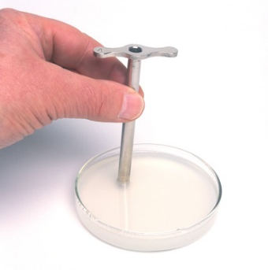 | 



- The Epsilometer test (E- test)
The E- test is a quantitative method used to determine MIC which applies both the dilution and diffusion of antibiotic into the medium. E-test is a ‘ready-to-use’ reagent strip with a predefined gradient of antibiotic for the determination of precise MIC values of a wide range of antimicrobial agents against different organism groups, when E-test is applied to the surface of an agar plate inoculated with the test strain, there is an instantaneous release of the antimicrobial gradient from the plastic carrier to the agar to form a stable and continuous gradient beneath and in the immediate vicinity of the strip.
When the E-test strip is placed on an agar surface, the antibiotic gradient on the strip is simply transferred to the agar matrix creating an imprint of the gradient on the strip in the agar. The bacterial growth becomes visible after incubation and a symmetrical inhibition ellipse centered along the strip is seen. The MIC value is read from the scale in terms of μg/mL where the ellipse edge intersects the strip.

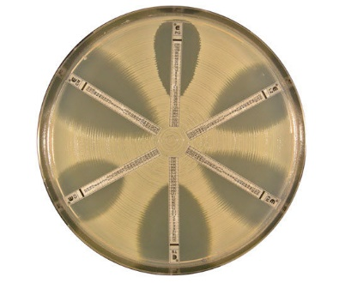

- Determination of the minimal inhibitor concentration (MIC) of a bacteriostatic substance by broth dilution method
The MIC procedure for testing antibiotics involves an antibiotic dilution assay, using either the wells of a micrometer plate or culture tubes. Each tube or well contains a different concentration of the agent and is inoculated with a fixed amount of the organism being tested. After incubation, the visible growth in the presence of the antibiotic is observed. The tube or well completely inhibiting growth of the organism in the presence of the smallest concentration of the antibiotic is expressed as the MIC.
To determine MBC: all visually negative tubes or wells (no visible growth after 18-24 hrs of incubation) are sub-cultured into agar plates and incubated for another 18-24 hrs at 37 ºC. The lowest dilution which shows a minimum of 99.9% killing on subculture is the MBC. Sub-culturing on an agar plate will dilute the antibiotic and if there were still surviving bacteria, growth on the plate will determine it.
The figure below is an example on serial dilution susceptibility testing for MIC determination.

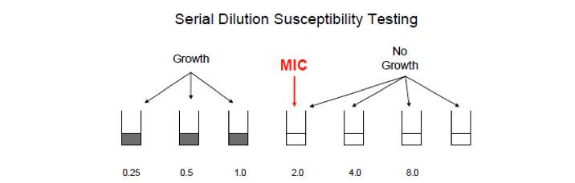
Example:
An antimicrobial susceptibility testing – the well (broth) dilution method was performed as following:
- 100 µL broth solution were first added to 8 wells.
- 100 µL of Gentamicin were added from a stock solution 512 μg/mL to the first well followed by 2-fold serial dilution in wells 2-8.
- 100 µL of bacterial inoculum was added after that to each well to give a final bacterial concentration of 5×10⁵ CFU/mL.

- Calculate the concentration of gentamycin in each well in μg/mL

 | 1st well | 2nd | 3th | 4th | 5th | 6th | 7th | 8th
Concentration after 2-fold serial dilution | 256 | 128 | 64 | 32 | 16 | 8 | 4 | 2
Concentration after the addition of bacterial inoculum | 128 | 64 | 32 | 16 | 8 | 4 | 2 | 1

- These wells were incubated over night at 37°C, after result inspection, the turbidity started at the 5th diluted well. Determine the MIC.

 | 1st well | 2nd | 3th | 4th | 5th | 6th | 7th | 8th
Results | C | C | C | C | T | T | T | T
C: Clear, T: Turbid

MIC = 16 μg/mL (4th test tube)

- 10 μl of each of the first four wells were sub-cultured on an agar plate using surface inoculation technique. The 3rd and 4th test tubes showed bacterial growth while the 2nd and 1st test tubes showed no growth at all. Determine the MBC.

 | 1st well | 2nd | 3th | 4th
Results | Zero colonies | Zero colonies | 4 colonies | 10 colonies

0.1% viable cells = 5×10⁵ CFU/mL× 10 μl (0.01 ml) × 0.1%= 5 CFU
This means that you can see up to 5 colonies on the agar plates to state that this nominated concentration killed at least 99.9% of the CFUs
MBC= 32 μg/mL (2nd test tube)
Practical part

Materials Required:
- 96-well microtiter plate with lid (sterile, flat-bottomed)
- Sterile micropipette tips
- Micropipettes (100 µL)
- Sterile broth media (nutrient broth or Mueller-Hinton Broth)
- Bacterial culture (adjusted to 0.5 McFarland standard, ~1×10⁸ CFU/mL)
- Antimicrobial agent (Gentamycin solution 32µg/mL or Erythromycin solution 128 µg/mL)
- Incubator set at 37°C

Procedure:

- Add 100 µL of sterile broth to all wells in columns 1 to 8.
- Add 100 µL of sterile broth to all wells of the first column. This will be your negative control.
- Do not add any solution to column 2 at this stage. This will be considered your positive control.
- Add 100 µL of gentamycin solution to well 3-5 of the first row.
- Add 100 µL of gentamycin solution to well 6-8 of the first row.
- Mix well by pipetting up and down several times.
- Transfer 100 µL from well 1A to well 1B, mix thoroughly.
- Continue this two-fold serial dilution across the row (wells B to H), transferring 100 µL each time and mixing.
- After well H, discard 100 µL to maintain equal volumes.
- Dilute the standardized bacterial culture 1:100 in broth to get ~1×10⁶ CFU/mL.
- Add 100 µL of the diluted bacterial inoculum to each well from columns 2 to 8.
- Incubate the 96 well plate at 37°C overnight
- Read your results and record them in a table using signs (+) and (-) for presence and absence of growth, respectively
- Calculate the MIC, which is the lowest concentration of bacteriostatic substance in the well showing no growth

well number | 1 | 2 | 3 | 4 | 5 | 6 | 7 | 8
Concentration
Results

