Experiment 9
Sterility testing of a pharmaceutical product
Introduction:
Is there any microbiological test performed on these final products?? And is it essential???
Firstly, watch this video:
https://www.youtube.com/watch?v=RAH0FLfiig0&list=PLf-BeYf_KaMt02E_ApBp_XpMX-5xFo-l0&index=3
Pharmaceutical industries based on their manufacturing pattern can be broadly classified into the following categories:

- Sterile products
- Injectables, sterile ophthalmic drops, monoclonal antibodies (MAbs) and vaccines.
- Sterile pharmaceutical ingredients, medical devices and materials claimed to be sterile undergo strict sterility testing to ensure they adhere to regulations.
- The sterile products are produced in the cleanroom environment free from any microbial contamination.
- The testing methods which ensure the product sterility state that a positive result (microbial growth) after 14 days at appropriate temperature (7 days incubation at 20 °C - 25 °C followed by 7 days incubation at 30 °C - 35 °C) is considered a failure, whereas negative results show that the product is sterile.
- The sterile products can be produced either by following aseptic manufacturing techniques or terminal sterilization.

- Non- sterile products
- Tablets, capsules, ophthalmic drugs
- Unlike sterile pharma manufacturing, non-sterile pharma products do not require the cleanroom environment to be completely free from any microbial presence.
- Non- sterile products tend to have moderate to low contamination control
- Acceptance criteria
- Bioburden _ number of recoverable viable organisms
- Absence of objectionable organism

A microbial control strategy and risk management are used to identify and prevent microbial contamination that could compromise the quality of the product.
Sterility testing of pharmaceutical products is required during the sterilization validation process. As per USP requirements, sterility testing is an official test to determine suitability of a lot for treatment.
Providing adequate and reliable sterility test data is an important quality assurance issue.
In this experiment we will talk about sterility of the media, Sterility testing of sterile and Non-sterile pharmaceutical products, and endotoxin Test (LAL Test).

Sterility of the media
There are mainly two types of media that are used in sterility:
  - Fluid Thioglycollate Medium (FTM)
For detection of both aerobic and anaerobic bacteria.
  - Tryptone Soya Broth or Soyabean Casein Digest Medium (TSB or SCDM).
Primarily intended for the culture of both fungi and aerobic bacteria.

Sterility check for the media
This is a pre-requisite step, which states that the sterility testing medium must not contain any contamination. To ensure the media is sterile (free from any microbial contamination), prepare FTM and TSB media and incubate the same at appropriate temperatures for a total of 14 days. There should not be any turbidity in the media after the said period.
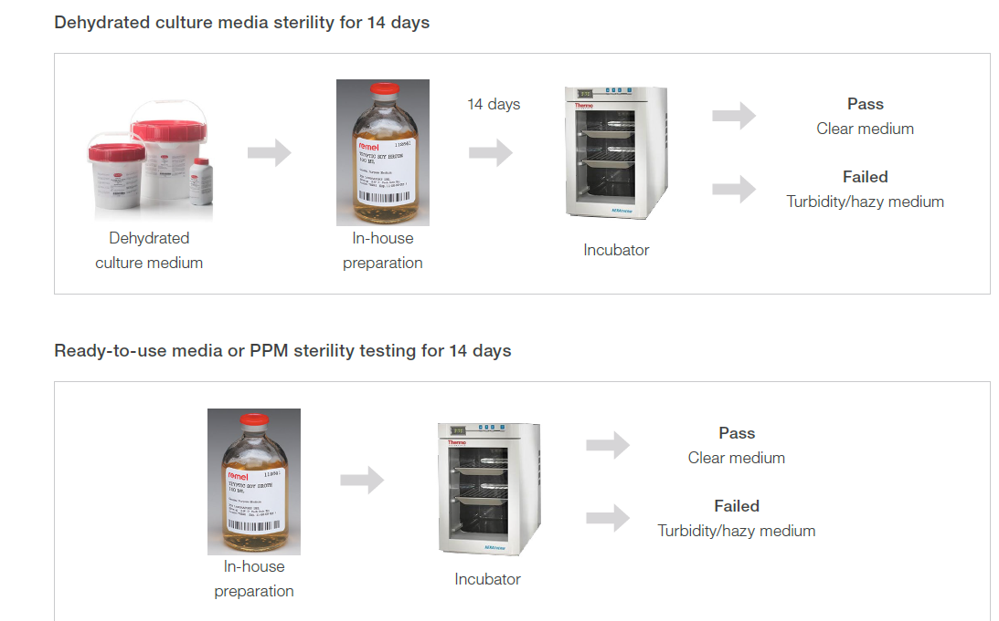
Sterility testing of sterile pharmaceutical products
To check the sterility of the product, each raw material and component used in the drug manufacturing must pass the sterility test.
For sterile products, the expectation and limit for the contamination has been already set by the regulatory bodies. Any out of specification product must be rejected and investigation must be carried out to identify the root cause.

The analysis must be carried out by using:
- Membrane Filtration and
- Direct inoculation
In each of the mentioned methods, the product sterility is investigated using appropriate culture media for recommended temperature and duration.

- Membrane filtration:
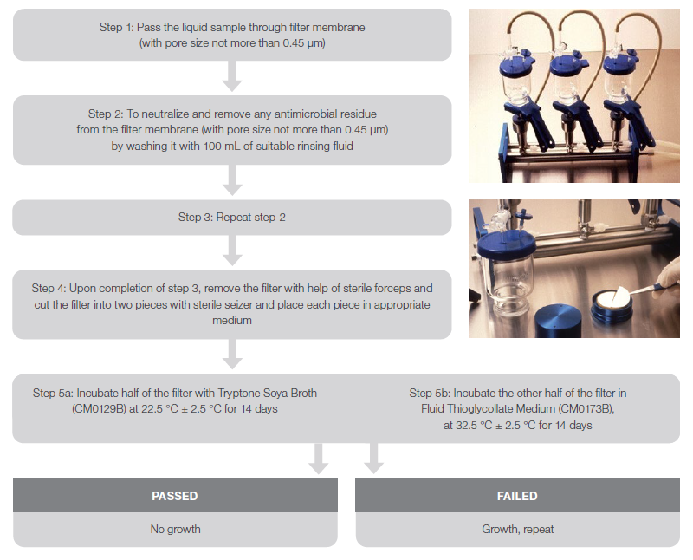
- Direct inoculation:
For liquid samples, 10-fold dilution is done and for solid samples 100 folds’ dilution is done using a suitable diluent.
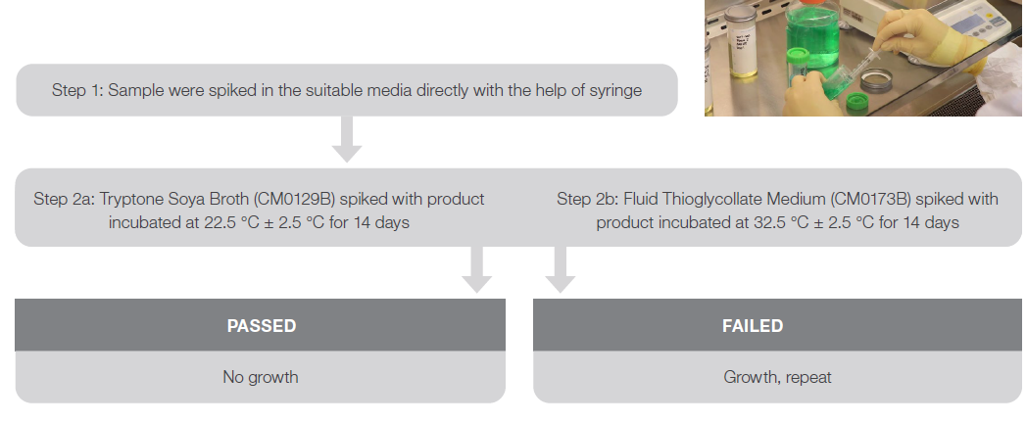
Sterility testing of Non- sterile pharmaceutical products
Unlike sterile product manufacturing, the manufacturing of non-sterile pharmaceutical products does not require the cleanroom environment to be completely free from any microbial presence.

There are acceptance limits set for these industries, which align with the regulatory acceptance guidelines to manufacture non-sterile products. Further, they test for objectionable microorganism presence in the product.

The basic tests done in non-sterile pharmaceutical industry for microbial identification is a Microbial enumeration test (microbial counting test) for the quantitative counting of viable microorganisms and the determination of the absence of specified microorganisms in finished pharmaceutical products and raw materials.

The methods for enumeration of microorganisms from pharmaceuticals includes membrane filtration and conventional plate count (including pour-plate method, surface- spread method).

The specific enrichment procedures depending on the target specified microorganism that must be absent, as required by a product monograph. Products which are insoluble or immiscible in water must be appropriately treated to obtain a suspension suitable for the test procedures.
Prepare the sample in a manner to achieve a uniform solution or suspension. This is critical because microbial contamination is not evenly dispersed throughout a lot or sample of product. Use conventional mechanical and shaking methods to the extent that original numbers and types of microorganisms are not altered in the product.
Endotoxin test (LAL test)
Bacterial endotoxin is a lipopolysaccharide found in the cell membrane of Gram-negative bacteria which may cause adverse events in patients such as, but not limited to fevers, headaches, inflammation, nausea, chills, vomiting, hypotension, lung toxicity, Toxic Anterior Segment Syndrome, abortion or death when injected into the blood stream. Therefore, all sterile drugs, medical devices and combination products must meet bacterial endotoxin specifications. Historically, in vitro Limulus Amoebocyte Lysate (LAL) assays based on the gel clot method have been used to detect and quantify bacterial endotoxin in pharmaceutical products.

The LAL reagent is derived from the amoebocyte lysate of the horseshoe crab Limulus Polyphemus, and it can react specifically with microbial lipopolysaccharides to give a gel even at very high dilutions.

The Gel-Clot Method is a qualitative and Quantitative assay that detects Gram-negative bacterial endotoxin based upon a reaction between lysate and endotoxin which results in a firm clot formation. For samples with endotoxin, the endotoxin amount present in a test sample is calculated by diluting the sample to determine the assay endpoint where a clot does not form. If no clot forms in the verified dilution from the inhibition and enhancement testing, the sample does not contain detectable endotoxin.
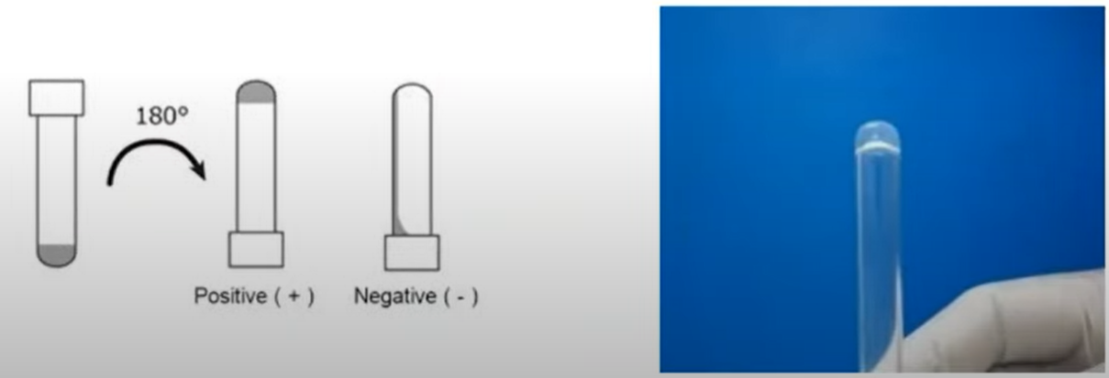

Practical Part

Part 1: For a sterile product
- Apply aseptic technique
- Make a file mark on the neck of the ampoule and swab the exterior round the mark with antiseptic
- Open the ampoule and transfer 1 ml samples with a sterile pipette or syringe into a test tube containing TSB medium
- Incubate and record results and conclusions.

Part 2: Microbial Count of non-sterile products

- For Water Soluble Non-Sterile Solid Product
- Apply aseptic technique
- In a sterile petri dish Weight 5 tablets and record their weight
- In a sterile mortar and pestle, grind the weighted tablets
- Transfer 0.1g of the powder and dissolve it in 1 ml sterile distilled water using Eppendorf tube
- Make 1:10 serial dilution two times using Eppendorf tube containing 900 µL sterile water
- Transfer 100 µl from each tube into the surface of agar plate
- Use L- shape rod to spread the sample over the agar plate
- Incubate the plates at 37 °C for 48 h
- Count the cells and identify them under the microscope

- For Water Soluble Non-Sterile Semi Solid Product
Experimental:
Repeat the same procedure as described in part (i) from step 4-9. Apply aseptic technique

Part 3: Endotoxin Test (LAL Test):

- Label 2 microcentrifuge tubes the first as test (T-tube) and the second as reference (R-tube).
- Transfer 0.5 ml of the test solution into the T-tube.
- Transfer 0.5 ml of the reference endotoxin solution into the R-tube.
- Add 0.5 ml of the LAL reagent to each of the two solutions above and mix gently.
- Incubate the 2 reaction mixtures for 60 minutes.
- Invert each reaction tube 180° and observe the presence of a firm gel, which remains in place upon inverting the tube, that indicates a positive result.

