

Hashemite University
Faculty of Pharmaceutical Sciences
Department of Pharmaceutics and Pharmaceutical Technology

Practical Pharmaceutical Microbiology
(131701341)
Reports
Section number :
Group number:

Student name | Student number

Complied by: MSc. Mai Jaber
2023

Experiment 2
Preparation of culture media under aseptic conditions and Quality assurance –microbial monitoring of environment

No. | Student name | Section | Date | Group no.
1
2
3
4
5
- Aim of Experiment:

- Results table:
After 24 - 48 hrs of incubation at 37ºC, do your prepared plates and broths appear to be sterile?

Sources of contamination | Plate number | Section | Label | Observation (Sterile/ Contaminated)
Contamination from hands | 1 | 1
Contamination from hands | 1 | 2
Contamination from hands | 1 | 3
Contamination from hands | 1 | 4
Contamination from mouth | 2 | 1
Contamination from mouth | 2 | 2
Contamination from air | 3 | -
Contamination from air | 4 | -
Contamination from water | 5 | 1
Contamination from water | 5 | 2
Contamination from surfaces | 6 | 1
Contamination from surfaces | 6 | 2
Contamination from surfaces | 6 | 3
Contamination from surfaces | 6 | 4

Page number ( )

- Discuss your results for all experiments:

- Is our hand contaminated by microorganism? What is the effect of hand wash and hand hygiene on these microorganisms?

- Is our mouth contain microorganism? if it is present, what is the effect of mouth wash on these microorganisms?

- Compare the quality of air between open air condition and Laminar air flow condition.

- Explain the effect of water sterilization by autoclave on its microbial content

Page number ( )
- Are our surfaces contaminated by microorganism? What is the effect of disinfectant on surface sterility? Does the surface 3 and 4 contaminated by microorganism? Compare the microbial load and type between the 4 sections.

- Conclusion:

Based on your previous answer, what conclusion can be made regarding our surrounding environment?

Page number ( )
Experiment Report Workload Distribution Table
¹Mention the name of the student/ group member who did arrange the work related to the current experiment group report/work management.
²Section or part of the group report
³Mention the name of student/the group member who took responsibility of the specified group report section
⁴Relative to the whole workload used to prepare the current group report.

Coordinator for
Current Experiment¹:
Section² | Student Name³ | Percentage of the Performed workload⁴

Page number ( )

Experiment 3
Culturing Methods and Plating Techniques

No. | Student name | Section | Date | Group no.
1
2
3
4
5

Aim of Experiment:

Results:

- Attach the picture for each student plate showing your results with labeling

- Attach or draw the picture for your broth culturing media
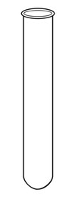

Attach these pictures to your report IMMEDIATELY after this page of the report.

Page number ( )
Discussion:
- Each student should describe the appearance (Colonies amount or density) of his/her plate (the four quarter). if your results are not as expected, suggest the possible reasons for these results.

- Student 1:

- Student 2:

- Student 3:

- Student 4:

- Explain the changes for your broth culturing sample (test tube sample after incubation for 24 hours?

Page number ( )

- What is the effect of forgetting to flam the inoculum loop after the first quarter plate streak?

- During streak plate method we should sterilize the inoculation loop before streaking on quarter 2, 3 and 4. What will happen if you didn’t allow the loop to be cool before start streaking in quarter 3. (Draw the expected result of the plate after incubation and describe the appearance of each quarter (Colonies amount or density))

Quarter1:

Quarter2:

Quarter3:

Quarter4:

Page number ( )

Experiment Report Workload Distribution Table
¹Mention the name of the student/ group member who did arrange the work related to the current experiment group report/work management.
²Section or part of the group report
³Mention the name of student/the group member who took responsibility of the specified group report section
⁴Relative to the whole workload used to prepare the current group report.

Coordinator for
Current Experiment¹:
Section² | Student Name³ | Percentage of the Performed workload⁴

Page number ( )

Experiment 4
Bacterial Identification
Simple staining, Gram staining and differential medium

No. | Student name | Section | Date | Group no.
1
2
3
4
5

Aim of Experiment:

Results and discussion:

- After you examine the slides under microscope, describe the following:

Bacteria type | Gram reaction | Cell shape | Cell arrangement
Escherichia coli
Staphylococcus aureus

- Draw the shape of each type of bacteria as you observed under microscope:

Escherichia coli | Staphylococcus aureus

Page number ( )
- Do the microorganisms have the appropriate expected appearance, or there was deviation in appearance, if yes, describe the problem you had, the probable causes and suitable corrective actions you can make.

- Draw the results of Streaking a MacConkey agar plate.

- Discuss the results of Streaking a MacConkey agar plate.

Page number ( )

Experiment Report Workload Distribution Table
¹Mention the name of the student/ group member who did arrange the work related to the current experiment group report/work management.
²Section or part of the group report
³Mention the name of student/the group member who took responsibility of the specified group report section
⁴Relative to the whole workload used to prepare the current group report.

Coordinator for
Current Experiment¹:
Section² | Student Name³ | Percentage of the Performed workload⁴

Page number ( )

Experiment 5
Sterilization Methods and Principles
No. | Student name | Section | Date | Group no.
1
2
3
4
5

Aim of Experiment:

Results:

After 24 - 48 hrs of incubation at 37ºC, do your prepared plates appear to be sterile?

Test | Plate number | Section | Label | Observation (Sterile/ Contaminated)
Red heat sterilization | 1 | Section 1
Red heat sterilization | 1 | Section 2
Red heat sterilization | 1 | Section 3
Red heat sterilization | 1 | Section 4
Sterilization by Ultraviolet Light | 2 | Section 1
Sterilization by Ultraviolet Light | 2 | Section 2
Test for moist heat sterilization (autoclave) | 3 | _
Test for moist heat sterilization at atmospheric pressure (temperature 100ºC) | 4 | _
 | 5 | _

Discussions:

- Red heat sterilization

- Rank the quadrants from that with the most growth to the least growth.

Page number ( )
- Was ethanol 70% sufficient for sterilization of the wire loop, explain?

- Was red heat sufficient for sterilization of the wire loop, explain?

- Sterilization by Ultraviolet Light:
Was UV radiation sufficient for killing the microorganism? Dose UV light penetrate the paper and the aluminum foil? Explain your results.

- Sterilization by autoclave:

Was autoclaving sufficient for killing the microorganism? dose the autoclaved bacterial suspension clear or turbid?

Page number ( )
- Moist heat sterilization at atmospheric pressure (temperature 100ºC) testing plates:
Compare the two plates after two time points and write down your comments.

Conclusion:
Based on your results, compare between the efficacy of the different sterilization technique in term of their Sterilization or decontamination efficacy and the time required to achieve sterilization.

Page number ( )

Experiment Report Workload Distribution Table
¹Mention the name of the student/ group member who did arrange the work related to the current experiment group report/work management.
²Section or part of the group report
³Mention the name of student/the group member who took responsibility of the specified group report section
⁴Relative to the whole workload used to prepare the current group report.

Coordinator for
Current Experiment¹:
Section² | Student Name³ | Percentage of the Performed workload⁴

Page number ( )

Report
Experiment 6
Testing of Disinfectants
No. | Student name | Section | Date | Group no.
1
2
3
4
5

Aim of Experiment:

Results:

- The qualitative suspension tests
After 24 - 48 hrs of incubation at 37ºC, each test tube (each subculture) should be examined whether it is turbid ‘growth (+)’ or clear ‘no growth (-)’.
 | Alcohol concentration
Time (min) | 35% | 70% | 95%

- The Quantitative Suspension Test
After 24 - 48 hrs of plate incubation at 37ºC, count bacterial colonies ranging from 30 to 300 per plate. Counts more than 300 colonies; are reported as TNTC (Too Numerous to Count).
Dilution Factor |  | # Of CFUs
Dilution Factor | Control Series |  | Disinfectant Series
10¹
10²
10³
10⁴
10⁵

Page number ( )
Discussions:

- The qualitative suspension tests
Discuss the results you obtained and write your comments about them. (The effect of time and ethanol concentration on disinfectant activity)

- The Quantitative Suspension Test
Discuss the results you obtained and write your comments about them. Calculate the microbicidal effect (ME) and explain what does it mean.

- Extra example
Calculate the ME for 70% ethanol which was used during a quantitative suspension test and explain what does it mean, knowing that the subculture step was performed using surface inoculation technique:
Dilution Factor | # of CFUs
Dilution Factor | Control Series |  | Disinfectant Series
10¹ | TNTC |  | 150
10² | TNTC |  | 43
10³ | TNTC |  | 0
10⁴ | 279 |  | 0
10⁵ | 109 |  | 0

Page number ( )

Experiment Report Workload Distribution Table
¹Mention the name of the student/ group member who did arrange the work related to the current experiment group report/work management.
²Section or part of the group report
³Mention the name of student/the group member who took responsibility of the specified group report section
⁴Relative to the whole workload used to prepare the current group report.

Coordinator for
Current Experiment¹:
Section² | Student Name³ | Percentage of the Performed workload⁴

Page number ( )

Report
Experiment 7
Qualitative methods used for the evaluation of bacteriostatic activity of different antimicrobial agents

No. | Student name | Section | Date | Group no.
1
2
3
4
5

Aim of Experiment:

Results:

After 24 hrs. of incubation at 37ºC, record the following?
Antimicrobial agent name | Microorganism name | Inhibition Zone’s length (mm)
E. coli | Erythromycin
E. coli | Cetrimide
S. aureus | Erythromycin
S. aureus | Cetrimide

Microorganism name | Antimicrobial agent name | Disc content | Inhibition Zone’s diameter (mm)
E. coli
S. aureus

Page number ( )
Discussions:

Part 1: Strip diffusion method

Based in your result, order the organism sensitivity towards the tested antimicrobial agent

Part 2: Disc diffusion method

- Record the presence of individual colonies within zones of inhibition, the occurrence of fuzzy zones or irregular zones (deviation from round shape). Mention the antibiotic(s) that had these phenomena.

- Classification of each microorganisms susceptibility against each tested antibiotic (Susceptible, Intermediate Susceptibility, Resistant) using CLSI tables.

- According to your results, to which antibiotic E. coli is most susceptible. Explain your answer?

Page number ( )
- According to your results, to which antibiotic S. aureus is most susceptible. Explain your answer?

Conclusion and comments:

Selected data from CLSI table:

Antimicrobial agent | Disc code | potency | Zone of inhibition diameter (mm)
Antimicrobial agent | Disc code | potency | Resistant | Intermediate | Susceptible
Amikacin | AK | 30 µg
E.coli and S.aureus |  |  | ≤ 14 | 15-16 | ≥ 17
Amoxicillin | AML | 30 µg
E.coli and S.aureus |  |  | ≤ 22 | 23-30 | ≥ 31
Cefepime | FEP | 30 µg
E.coli and S.aureus |  |  | ≤ 14 | 15-17 | ≥ 18
Gentamicin | CN | 120 µg
E.coli and S.aureus |  |  | ≤ 6 | 7-9 | ≥ 10

Page number ( )

Experiment Report Workload Distribution Table
¹Mention the name of the student/ group member who did arrange the work related to the current experiment group report/work management.
²Section or part of the group report
³Mention the name of student/the group member who took responsibility of the specified group report section
⁴Relative to the whole workload used to prepare the current group report.

Coordinator for
Current Experiment¹:
Section² | Student Name³ | Percentage of the Performed workload⁴

Page number ( )

Report
Experiment 8
Determination of the minimal inhibitor concentration (MIC) of a bacteriostatic substance

No. | Student name | Section | Date | Group no.
1
2
3
4

Aim of Experiment:

Results:
Microorganism tested: ___________________
Antimicrobial agent evaluated: _____________________
Antimicrobial agent concentration: ___________________
Part 1: Agar diffusion method
After 24 hrs. of incubation at 37ºC, record the following?
Sector | Concentration (µg/ml) | Y  Diameter of the zone of inhibition  (mm) | Z  Diameter of the well  (mm)
1
2
3
4

Part 2: Broth dilution method
After 24 hrs. of incubation at 37ºC, read your results and record them in a table using signs (+) and (-) for presence and absence of growth, respectively

Tube number | 1 | 2 | 3 | 4 | 5 | 6 | 7
Results

Negative control is represented in test tube number: _______________
Positive control is represented in test tube number: _________________

Page number ( )
Calculation:
Calculate the MIC using both Agar diffusion method and broth dilution method
- Show your detailed calculation
- Insert Excel Sheets (Tables & Charts) immediately after this page

Part 1: Agar diffusion method

Page number ( )
Part 2: Broth dilution method
Tube number | 1 | 2 | 3 | 4 | 5 | 6 | 7
Results
Concentration µg/ml

Conclusions and Comments:

- Agar diffusion method:
MIC of…………………………= …………………………………………..

- Broth dilution method:
MIC of…………………………= …………………………………………..

- Write your expectations for the MBC values for both antibiotics, do you expect to have values similar to MIC or different values, explain your answer.

Page number ( )

Experiment Report Workload Distribution Table
¹Mention the name of the student/ group member who did arrange the work related to the current experiment group report/work management.
²Section or part of the group report
³Mention the name of student/the group member who took responsibility of the specified group report section
⁴Relative to the whole workload used to prepare the current group report.

Coordinator for
Current Experiment¹:
Section² | Student Name³ | Percentage of the Performed workload⁴

Page number ( )

Report
Experiment 9
Data handling and interpretation associated with heat sterilization processes

No. | Student name | Section | Date | Group no.
1
2
3
4

Aim of Experiment:

Part 1:

- Plot a graph of the following data using semi-log paper of cells number versus time (min) and calculate the D value for each plot.

Time of heating(min) | viable counts of survivors at temperature indicated
Time of heating(min) | 110 | 115 | 117.5 | 121
“Data for each group are provided in another file”

- Insert Excel Sheets (Charts) immediately after this page

- Fill the following Tables according to your graph.

Temperature | D-value (min)

Page number ( )
Show your details calculation of any D-value. Select one temperature

- Using the values obtained calculate z- value for the spores.
Z- value

Insert temperature vs. D- Value plot (Charts) immediately after this page
Show your details calculation of Z-value.

Part 2:
Calculate the F₀ equivalent of the following time/temperature relationships
Temperature (C^{o)} | Time (min) | F₀
115-118 | 30
121-124 | 15
126-129 | 10
134-138 | 3

Show your details calculation of F₀-value “select one of the above value”

Page number ( )
Part 3:
Determine the F0 value of the autoclaving process whose time/temperature profile is presented below. It is suggested that the F0 value to be determined only for temperatures above 100 °C.
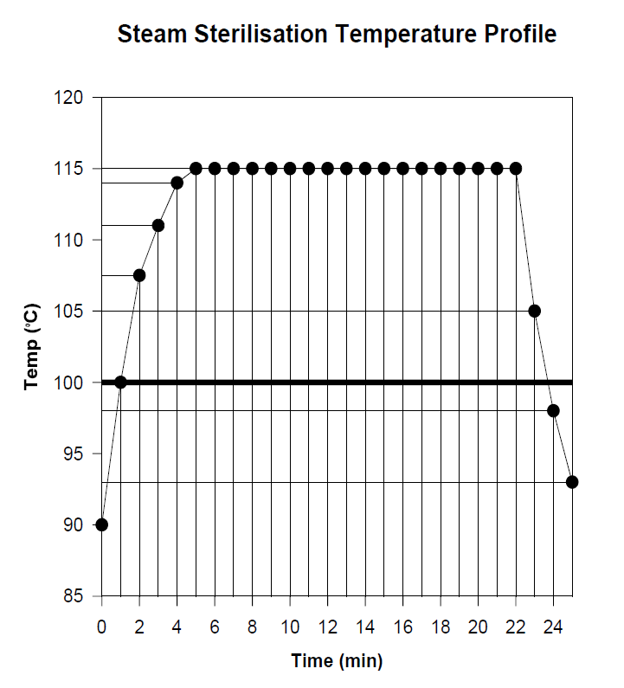

Page number ( )
Part 4:
- What would be the survival level of a Biological Indicator Organism whose spores have a D10 value of 1 min at 121 °C assuming initial challenge of 10⁷ spores and the above F₀ value.

What F treatment would be necessary to reduce the probability of survival of the same Biological Indicator challenge (10⁷ spores) to not more than 10⁻⁶, Assuming that D value=1 min.

Page number ( )

Experiment Report Workload Distribution Table
¹Mention the name of the student/ group member who did arrange the work related to the current experiment group report/work management.
²Section or part of the group report
³Mention the name of student/the group member who took responsibility of the specified group report section
⁴Relative to the whole workload used to prepare the current group report.

Coordinator for
Current Experiment¹:
Section² | Student Name³ | Percentage of the Performed workload⁴

Page number ( )

Report
Experiment 10
Sterility testing of a pharmaceutical product

No. | Student name | Section | Date | Group no.
1
2
3
4

Aim of Experiment:

Part 1: Sterility test of a sterile pharmaceutical product
- Which type of sterility testing method we used to test a sterile water of injection.

- Mention the two types of media that should be used in sterility testing

Part 2: Sterility testing of Non- sterile pharmaceutical products
Knowing that:
- The test was performed using 2 tablets (their weight was about 1g)
- And the microbial count in each Petri dish was as the following:
Plate | Microbial count
1/10 | TNTC
1/100 | 346
1/1000 | 154
1/10000 | 11

Then:

- Calculate the microbial count per 1g dosage

- Calculate the microbial count per 1 tablets
Page number ( )

Experiment Report Workload Distribution Table
¹Mention the name of the student/ group member who did arrange the work related to the current experiment group report/work management.
²Section or part of the group report
³Mention the name of student/the group member who took responsibility of the specified group report section
⁴Relative to the whole workload used to prepare the current group report.

Coordinator for
Current Experiment¹:
Section² | Student Name³ | Percentage of the Performed workload⁴

Page number ( )

