Experiment 5
Sterilization Methods and Principles

- Objectives:
The aim of this experiment is to:
• Understand the different methods of sterilization.
• Evaluate the effectiveness of various sterilization methods under laboratory conditions.

- Introduction

- Sterilization is the process of eliminating all forms of microbial life, including bacteria, viruses, fungi, and spores, from surfaces, instruments, media, and other materials. It is essential for maintaining aseptic conditions in medical, laboratory, and industrial environments.

- Decontamination involves removing or neutralizing contaminants from objects or environments. Survivor curves are used to study the relationship between the duration or intensity of exposure and the fraction of surviving microorganisms.

- Survivor curves: They are plots of the logarithm of the fraction of survivors (microorganisms which retain viability following a sterilization process) against the exposure time or dose.

- Methods of Sterilization are:

- Physical Method
  - Thermal (Heat) Sterilization methods
Heat Sterilization: is the most widely used and reliable method of sterilization, involving destruction of enzymes and other essential cell constituents. Both dry and moist heat are used for sterilization. The process is more effective in hydrated state. This method of sterilization can be applied only to the thermostable products

- Moist Heat Sterilization
Moist heat uses steam at temperatures between 121°C to 134°C and is highly effective for sterilizing metal instruments, glassware, and culture media. Autoclaves are standard equipment in labs for moist heat sterilization, operating at 121°C for at least 15 minutes under pressure. It is more efficient than dry heat due to better penetration and protein denaturation.
• Boiling water (~100°C) is a simple method but does not kill all spores.
• Pasteurization is an application of moist heat. It is used for food and beverages, applying lower temperatures (e.g., 63°C for 30 mints or 72°C for 15 secs) to kill pathogens while preserving food quality.

- Dry Heat Sterilization

Dry heat sterilization employs high temperatures (160-180°C) for extended periods (up to 2 hours). It's used for materials that can withstand such heat, like glassware and metal tools.
• Incineration is a common method where items are burned (e.g., flaming an inoculation loop).
• Dry heat destroys bacterial endotoxins and is useful for sterilizing powders and oils.

- Moist vs. Dry Heat Comparison
• Moist heat is faster and more effective than dry heat.
• Moist heat requires penetration of both heat and moisture.
• Dry heat is suitable for materials that might corrode or degrade under moist conditions.
• Equipment for moist heat (autoclaves) is more complex.

  - Radiation Sterilization method

Radiation Sterilization many types of radiation are used for sterilization like electromagnetic radiation (e.g. gamma rays and UV light), particulate radiation (e.g. accelerated electrons). The major target for these radiations is microbial DNA.

- Radiation sterilization with high energy (Gamma rays and electron beams) are used for industrial sterilization of heat-sensitive items.

- UV-C light (200–280 nm, optimal at 265 nm) is used for disinfecting air, water, and surfaces. UV sterilization is limited by its poor penetration but is effective at the surface level. It forms thymine dimers in DNA, preventing replication.

- Radiation sterilization is generally applied to articles in the dry state; including surgical instruments, unit dose ointments, plastic syringes and dry pharmaceutical products
  - Filtration Sterilization method

Filtration removes microorganisms from liquids and gases using membrane filters. It is used for heat-sensitive solutions like vaccines and antibiotics, the major mechanisms of filtration are sieving, adsorption and trapping within the matrix of the filter material.
.
          - Filters have pore sizes (0.22um, 0.45um, 0.5um, 1um µm) that physically block microbes.
          - Materials include cellulose, nylon, or Teflon.
          - Used in pharmaceutical industry, sterile ventilation systems, and sterility testing.

- Chemical Method

1. Gaseous Sterilization
Uses gases like ethylene oxide (EtO) or formaldehyde. They act by alkylating proteins and DNA.
• Suitable for plastics, electronics, and other heat-sensitive materials.
• High penetration power but toxic and potentially carcinogenic.
• Requires proper aeration post-sterilization to remove toxic residues.

2. Liquid Sterilization
Submersion in chemicals like hydrogen peroxide is used when heat or radiation is not suitable.
• Effective for low levels of contamination.
• Hydrogen peroxide (35–90%) is a strong oxidizer used in medical fields.
• Shorter sterilization cycles (~28 min) than gaseous methods.
• Limited penetration and material compatibility.

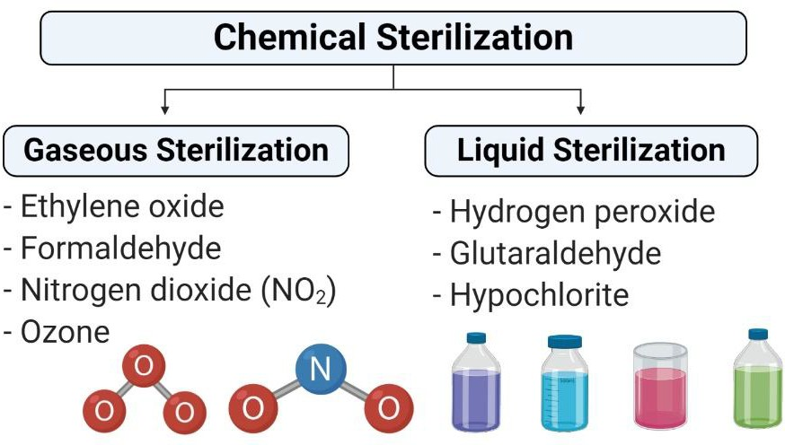

Practical Part

Test 1: Test for red heat sterilization

- Divide the nutrient agar plate into four quadrants and label 1 through 4.
- Quadrant 1 is your negative control. Do not touch it.
- Gently resuspend the bacterial suspension provided to you.
- Sterilize the wire loop by Bunsen burner. Then allow it to cool before picking up any microorganisms.
- Use the sterilized wire loop to inoculate a sample.
- Streak it on the surface of the second quadrant of petri dish.
- Sterilize the wire loop by Bunsen burner. Then allow it to cool before picking up any microorganisms.
- Use the sterilized wire loop to inoculate a sample.
- Immerse the loop in ethanol 70% in a 50 ml beaker.
- Wait to dry, and then Streak it on the surface of the third quadrant of petri dish.
- Sterilize the wire loop by Bunsen burner. Then allow it to cool before picking up any microorganisms.
- Use the sterilized wire loop to inoculate a sample.
- Sterilize the wire loop by Bunsen burner. Then allow it to cool before picking up any microorganisms.
- Streak it on the surface of the fourth quadrant of petri dish.
- Cover the plates with their lids, and incubate them at 37 °C for 24 hours.

Test 2: Test for Sterilization by Ultraviolet Light

In this practical, we are going to investigate the bactericidal effect of UV light as a function of exposure time in addition to evaluating its penetrating power through different materials.

- prepare a bacterial lawn by dipping a sterile cotton swab in a diluted overnight culture (of selected bacteria) and then spread the bacterial inoculum across the entire surface of a nutrient agar plate.
- covering part of the plate by a tin foil in one time and a piece of paper in the other.
- Place an inoculated plate under the UV lamp, with the lid removed, for each of the following exposure times: 2 or 5 minutes.
- Re-cover the plates with their lids, and incubate them at 37 °C for 24 hours.

Test 3: Test for moist heat sterilization at temperature above 100ºC (Autoclaving)

- Under aseptic technique, prepare a bacterial lawn by dipping a sterile cotton swab in a decontaminated (autoclaved) bacterial suspension provided to you, and then spread the bacterial swab across the entire surface of a nutrient agar plate.
- Cover the plate with their lids, and incubate them at 37 °C for 24 hours.

Test 4: Test for moist heat sterilization at atmospheric pressure and 100 ºC

- Place the two bacterial suspension test tubes provided to you in a water bath at 100 °C.
- After 5 min, take one test tube, wait to cool and prepare a bacterial lawn by dipping a sterile cotton swab in a test tube and then spread the bacterial inoculum across the entire surface of a nutrient agar plate.
- Cover the plate with their lids, and incubate them at 37 °C for 24 hours.
- After 15 min, take the second test tube, wait to cool and prepare a bacterial lawn as we did in the previous step.
- Cover the plate with their lids, and incubate them at 37 °C for 24 hours

