

T103/TM103
Computer Organization and Architecture
Midterm Examination (MTA)
Solution
Spring Semester 2023/2024

Date: ?? /???/2024

Time Allowed: 1.5 Hours | Number of Exam Pages: 3  (including this cover sheet)

Instructions:
- Total Marks: 60
- This exam consists of two parts.
- ALL questions must be answered in the External Answer booklet.
- Be sure you write your name and ID on the External Answer booklet.
- Programmable Calculators are not allowed.

Part 1: Multiple Choices questions (5 x 2 = 10 Marks)

Answer all the following questions by choosing the most correct statement.

- How many milliseconds (ms) are in 0.5 seconds?

  - 50000
  - 0.005
  - 500
  - None of the choices

- The logical operator "NOR" returns a 1 value when:

  - Exclusively all inputs are 1.
  - Any input is 1.
  - Any input is 0.
  - Exclusively all inputs are 0
- The biggest decimal number that can be represented in a 6-bit unsigned whole numbering system is:

  - 16
  - 31
  - 64
  - 63

- A computer speed is mainly affected by:

- The ROM.
- The number of I/O devices.
- The CPU’s clock speed.
- All the choices.

- What is the complement of the expression $F=\overline{x+y+z}$?

- $\overline{x. y.z}$
- $\overline{x }+\overline{y}+\overline{z}$
- $x+y+z$
- None of the choices.

________________________________________________________________

PART 2: ALL QUESTIONS ARE REQUIRED [50 Marks]
Remark for questions in Part 2:
Kindly consider any equivalent answers and allow for partial marks to be awarded accordingly.

Q-1: Answer the following questions: [6 marks]
- What is a cache memory?
- Name two types of ports in a computer (whether old or new)
- Name two levels of the computer hierarchy.
Answer: [6 marks: 2 marks for each part]
- Cache is a type of temporary memory that can be accessed faster than RAM
- Any two types of ports. For example, USB, serial, parallel, PS/2…
- Any two levels: User’s level, High-Level Language Level, Assembly Language Level’ System Software Level, Machine Level, Control Level, Digital Logic Level
Q-2: Represent in floating-point excess16 the number -57.75₁₀. [7 marks]

Answer: (7 marks: 1 mark for the sign, 3 marks for each of the exponent and the significand)

FP-excess 16 | 1 | 1 | 0 | 1 | 1 | 0 | 1 | 1 | 1 | 0 | 0 | 1 | 1 | 1 | [7 marks]

Q-3: Represent the decimal number (-95) in binary using 8-bit sign magnitude, one’s complement, and two’s complement: [9 marks]
Answer: [9 marks: 3 marks for each representation]
8-bit sign magnitude | 11011111
one’s complement | 10100000
two’s complement | 10100001

Q-4: Perform the following base conversions: [14 marks]
- (151)₁₀ = (10010111)₂ [2 marks]
- (01100110.01)₂ = (146.2 )₈ [4 marks: 2 marks for the integer ; 2 marks for the fraction ]
- (2B .4)₁₆ = (43.25)₁₀ [4 marks: 2 marks for the integer part ; 2 marks for the fraction part]
- (674)₈ = (1BC) ₁₆ [4 marks: award partial marks if the conversion to binary is correct]

Q-5: Given the following truth table: [14 marks]
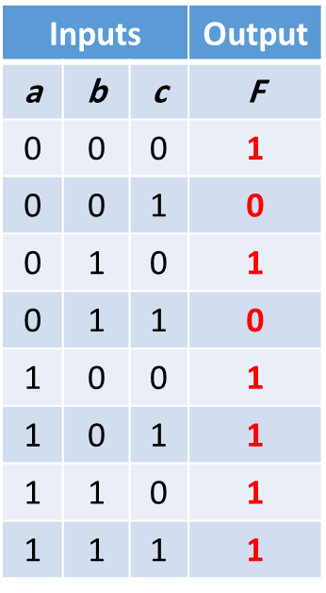
- Deduce from the above table, the Sum of Product form of F.
- Draw the K-map of the function F, showing the groupings you have selected.
- Deduce the simplified F from the K-map.
- Draw the logic gate representation (diagram) of the simplified F.

Answer: (14 marks)
- (3 marks: 0.5 marks for each minterm)
F(a,b,c)= a’b’c’ + a’bc’ + ab’c’ + ab’c + abc’ + abc

- (6 marks: 3 marks for the proper positioning of 1’s; 3 marks for proper grouping)
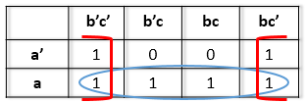
- F= a + c’ (3 marks: Deduct 1 mark if the student added a redundant term)
- Logic diagram (2 marks)
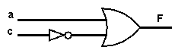

End of questions

