

Faculty of Computer Studies

T103/TM103: Computer Organization and Architecture

Mid-Term Assessment (MTA) - Makeup
Solution

Fall 2022/2023

Date: TBA

( 1.5 ) Hours | Time Allowed: | ( 4 ) | Number of Exam Pages:  ((including this cover sheet
Total Grade: 60

Instructions:

1- Write all your answers on the Answer Booklet.
2- Programmable calculators are not allowed.

Question Type | Number of questions | Max. Mark | Estimated time
Part 1: MCQ | 5 | 10 | 10 minutes
Part 2: Problems and Short essay questions | 5 | 50 | 60 minutes
Total |  | 60

Part 1: Multiple Choices questions (5 x 2 = 10 Marks)

Answer all the following questions by choosing the most correct statement
- A computer speed is mainly affected by:

- The ROM.
- The number of I/O devices.
- The CPU’s clock speed.
- All the above.

- 10 milliseconds are equivalent to:

- 10*10⁻³ microseconds
- 1*10⁻⁴ microseconds.
- 10*10³ microseconds.
- Both, b and c.

- Ports that send data as a series of pulses along one or two data lines are called?

- Serial.
- USB.
- Parallel.
- SATA.

- What is the complement of the expression $F=\overline{x+y+z}$ ?

- $\overline{x. y.z}$
- $\overline{x }+\overline{y}+\overline{z}$
- $x+y+z$
- None of the above.

- Which of the following is a valid statement?

- Full adders always have two inputs.
- Registers can be designed from D-Flip-Flops.
- Decoders are sequential circuits.
- Both, b and c.

_______________________________________________________________________________

PART 2: ALL QUESTIONS ARE REQUIRED [50 Marks]
Remark for questions in Part 2:
All of the answers below for the questions are considered ideal answers to be considered in correction. However, the tutor should expect student’s answers to be provided in some different style and format. Kindly consider these answers and allow for partial marks to be awarded accordingly.

Q-1: Given the following K-map of the function F: [6 marks]

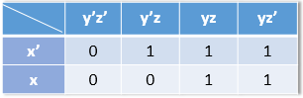
Deduce the simplified F from the K-map, showing how you have grouped the minterms.

Answer:
(6 marks: 2 marks for proper grouping, 4 marks for deducing the simplified F properly)

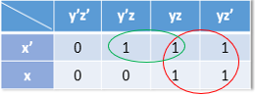

F=y+ x’z.

Q-2: Represent the decimal number (-91) in binary using 8-bit sign magnitude, and two’s complement: [8 marks]
Answer: [6 marks: 3 marks for each representation]
8-bit sign magnitude | 11011011
two’s complement | 10100101

Q-3: Given the floating-point notation excess16 diagram. Find the decimal number that it represents. [7 marks]

FP-excess 16 | 0 | 1 | 0 | 1 | 1 | 1 | 1 | 1 | 0 | 0 | 1 | 1 | 0 | 1

Answer: (7 marks: 1 mark for the sign, 6 marks for deducing the number from the exponent and the significand)

It represents the decimal number (+102.5)

Q-4: Below are the equations of the Boolean functions F and G:
$F=x^{'}y+(x+y)'$ , G=x’

Answer the following questions: [13 marks]

    - Draw the combinational circuit that implements the Boolean function F.
    - Draw the combinational circuit that implements the Boolean function G.
    - Using Truth Table, check whether F is equivalent to G or not.

Answer: (13 marks)

a$:F=x^{'}y+(x+y)'$ (5 marks)
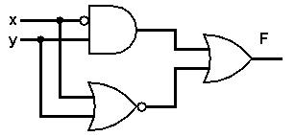
b$:G=x'$ (2 marks)
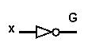
c: (6 marks)
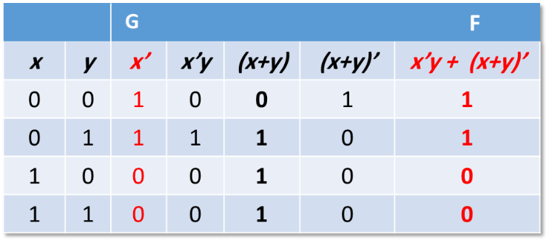

Q-5: Perform the following base conversions: [16 marks]
- (110.25)₁₀ = (01101110‬.01)₂ [4 marks: 2 marks for the integer ; 2 marks for the fraction ]‬‬‬‬‬
- (11101110.1)₂ = (356.4 )₈ [4 marks: 2 marks for the integer ; 2 marks for the fraction ]
- (2D)₁₆ = (45)₁₀ [2 marks]
- (1BC)₁₆ = (674)₈ [6 marks: award partial marks if the conversion to binary was correct 000110111100‬ ‬] ‬‬‬‬‬‬‬‬

___________________________________________________________________________
End of the Assessment.

