

Faculty of Computer Studies

T103/TM103: Computer Organization and Architecture

Mid-Term Assessment (MTA)
Solution

Fall 2022/2023

Date: TBA

( 1.5 ) Hours | Time Allowed: | ( 5 ) | Number of Exam Pages:  ((including this cover sheet
Total Grade: 60

Instructions:

1- Write all your answers on the Answer Booklet.
2- Programmable calculators are not allowed.

Question Type | Number of questions | Max. Mark | Estimated time
Part 1: MCQ | 5 | 10 | 10 minutes
Part 2: Problems and Short essay questions | 5 | 50 | 60 minutes
Total |  | 60

Part 1: Multiple Choices questions (5 x 2 = 10 Marks)

Answer all the following questions by choosing the most correct statement
- A 100KB file is equal, in bits, to:
- 0.8 Mbits.
- 100,000 bits.
- 800,000 bits.
- None of the above.

- Clock speeds in today’s microprocessors are measured in:
  - Kilohertz
  - Megahertz
  - Gigahertz
  - Terahertz
- What is the complement of the expression xy’ +z’?
- (x’ . y’)+ z
- (x’ . y) +z
- (x’+ y) . z
- None of the above.

- What is the Octal equivalent of the decimal number 17.5?
- 23.5
- 21.5
- 21.4
- None of the above

- Which of the following is true about Decoders?
- They have n inputs and 2^{n} outputs.
- They are combinational.
- Only one output is active at a time, based on the value present at the input lines.
- All the above

PART 2: ALL QUESTIONS ARE REQUIRED [50 Marks]
Remark for questions in Part 2:
All the answers below for the questions are considered ideal answers to be considered in correction. However, the tutor should expect student’s answers to be provided in some different style and format. Kindly consider these answers and allow for partial marks to be awarded accordingly.

Q-1: Represent the decimal number (-42.75) in floating point notation excess16. [7 marks]

Answer: (7 marks: 1 mark for the sign, 3 marks for each of the exponent and the significand)

FP-excess 16 | 1 | 1 | 0 | 1 | 1 | 0 | 1 | 0 | 1 | 0 | 1 | 0 | 1 | 1 | [7 marks]

Q-2: Answer the following questions: [10 marks]
- How are sequential circuits different from combinational circuits?
- Why are JK flip-flops often preferred to SR flip-flops?

Answer

- combinational circuits: A logic device whose output is always based entirely on the given inputs. sequential circuits: a logic device whose output is defined in term of its current inputs in addition to its previous outputs.
- Because the JK flip-flop is a simple modification of the SR flip-flop to ensure the state J=K=1 is never arising. It works just like a SR flip-flop and stores two bits of information, where J is serving as set input and K serving as reset.

Q-3: Below is the combinational circuit that implements the expression F. [10 marks]
- Write the equation of the outputs of gates 1, 2, and 3.
- What will be the value at the output if we have x=1; y=0; z=0?

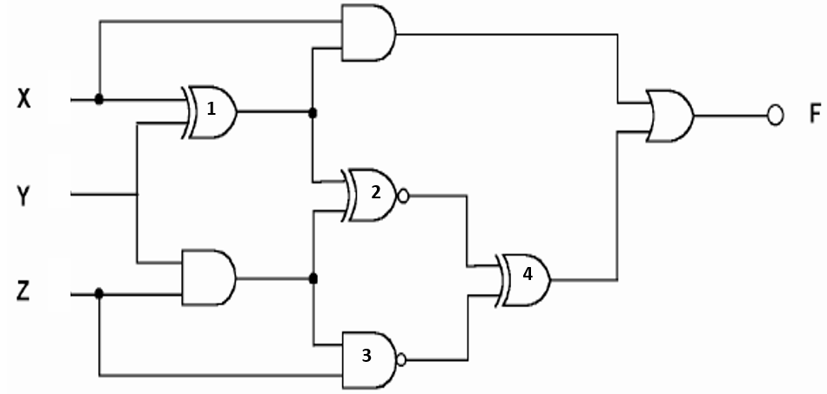

Answer: (10 marks)
- (6 marks)
1$:x⊕y$ 2$:\overline{(x⊕y)⊕(y.z)}$ 3:$\overline{\left(y.z\right). z}$

- The output will be 1. (4 marks)

Q-4: Given the following truth table: [14 marks]

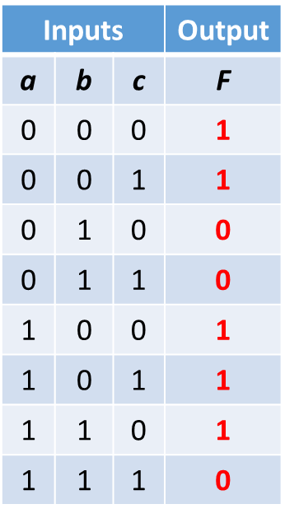
- Deduce from the above table, the Sum of Product form of F.
- Draw the K-map of the function F, showing the groupings you have selected.
- Deduce the simplified F from the K-map.
- Draw the logic gate representation (diagram) of the simplified F.

Answer:
- (2.5 marks: 0.5 marks for each minterm)
F(a,b,c)= a’b’c’ + a’b’c + ab’c’ + ab’c + abc’

- (4.5 marks: 2.5 marks for the proper positioning of 1’s; 2 marks for proper grouping)
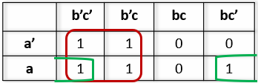

- F=b’ + ac’ (3 marks: Deduct 1 mark if the student added a redundant term)
- Logic diagram (4 marks. Deduct 1 mark if the student added redundant gates)
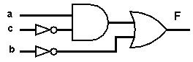
Q-5: Represent the decimal number (-92) in binary using 8-bit sign magnitude, one’s complement, and two’s complement: [9 marks]
Answer: [9 marks: 3 marks for each representation]
8-bit sign magnitude | 11011100
one’s complement | 10100011
two’s complement | 10100100
___________________________________________________________________________
End of the Assessment.

