

T103/TM103
Computer Organization and Architecture
Final Examination
Solution
Spring Semester 2023/2024

Date: ?? /??/2024

2 Hours | Time Allowed: |  | Number of Exam Pages: 7  ((including this cover sheet

Instructions:
- Total Marks: 100
- This exam consists of 3 parts.
- ALL questions must be answered in the External Answer booklet.
- Be sure you write your name and ID on the External Answer booklet.
- Programmable Calculators are not allowed.

Part I: Choose the most correct answer (20 marks)

This part consists of 10 questions carrying a weight of two marks each.

You should answer ALL the following:

- The number of registers in MARIE is:

- 7.
- 9.
- 13.
- 16.

- The unsigned 12-bit binary equivalent to the Hexadecimal number F6 is:

- 111111100000
- 000011110110.
- 11110110
- 000011110011

- Which of the following is not a sequential circuit?

- Full Adder
- Counter
- Multiplexer
- Both a and c.

- Based on what you have studied in this course, the smallest possible addressable unit of computer storage is the:

  - Bit.
  - Word.
  - Byte.
  - Register.

- For a 4-input XOR gate, the output will be 1 only if:

- All inputs are 1, exclusively.
- All inputs are 0, exclusively.
- The number of inputs equal 1 is odd.
- All inputs are equal.

- Which of the following is true about Static RAM?

- Needs refreshing.
- Used as Cache memory.
- Very cheap compared to DRAM.
- Both a and b.

- Which of the following is a characteristic of EEPROM?

- It is volatile.
- It can only be programmed once.
- Erasure is done by applying an electric field.
- None of the above.

- Which of the following is a valid statement?
- Flash memory is a volatile memory.
- Cache memory is faster than the registers.
- A Miss is recorded when data is found at a given memory level.
- None of the above.
- If we want to build a 64Kx32 word addressable RAM memory using only 4Kx16 RAM chips, then we need:

- 4 different 4Kx16 RAM chips.
- 8 different 4Kx16 RAM chips
- 32 different 4Kx16 RAM chips
- 16 different 4Kx16 RAM chips

- The CPU component responsible for storing some data or intermediate results is the:

- RAM.
- Register.
- Control Unit.
- Arithmetic Logic Unit.

______________________________________________________________

Part II: Short essay questions (30 marks)
This part consists of five questions carrying a WEIGHT OF 6 marks each.
You should answer all questions.
Remark for questions in Part 2:
All the answers below for the questions are considered ideal answers to be considered in correction. However, the tutor should expect student’s answers to be provided in a different style and format. Kindly consider these answers and allow for partial marks to be awarded accordingly.

- Answer the following questions:
- Name the two universal gates used in digital logic design.
- Represent an AND gate using NAND gates.

Answer: (6 marks: 3 marks for each part)
  - NAND and NOR.
  - AND-Gate using NAND:
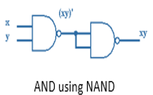

- Suppose that we have a 16M * 64-bit memory module (Word addressable):
- What is the word size?
- How many bits are needed to represent each address in this module? Show your calculations.

Answer: (6 marks: 2+4)
  - The word size is 64 bits.
  - 16M*64 = 16M*1 WORD= 2⁴*2²⁰=2²⁴ 24 bits are needed

- Using MARIE instruction set, find the equivalent assembly codes of the following binary instructions.
- 0011 1100 0110 0000.
- 1001 1111 0101 0000.

Answer: (6 marks: 2 marks for each instruction)
- Add C60
- Jump F50

- Referring to MARIE ISA, what do Store X and Clear do?

Answer: (6 marks)
Store X is used to store the content of AC at address X. (3 marks)
Clear is used to set the Accumulator to zero (3 marks)

- Draw the truth table of the full-adder.

Answer: (6 marks: 2 marks for proper input columns, 2 marks for the Sum, 2 marks for the carry-out)

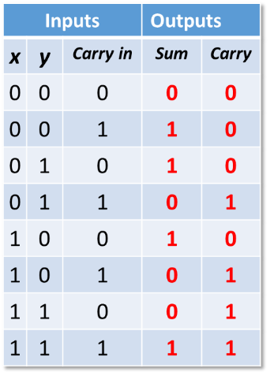

______________________________________________________________________________________

Part III: Numerical problems (50 marks)
This part consists of four questions carrying a weight of 50 marks.
You should answer all questions.

- Suppose that you have the following for a certain piece of code written using MARIE instructions. Fill in the unknown cells with proper values (20 cells with “?”) [10 marks]
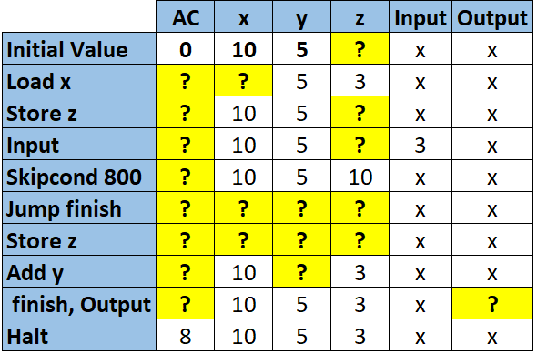
Answer: (10 marks, 0.5 marks for each cell)
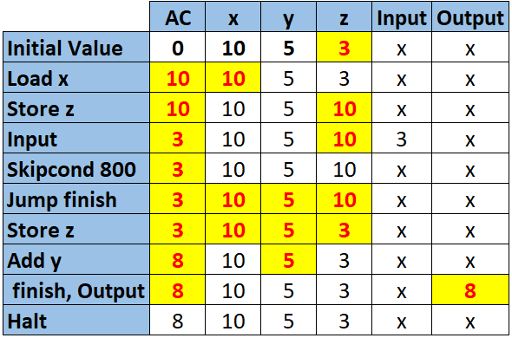

- Suppose we have the following MARIE code: [12 marks]

Load 300
Add 400

Knowing that AC=400 before executing the two instruction, and the memory and register R1 containing the values below, determine the actual value that will be found in the accumulator AC after executing each instruction in each mode, and fill in the table below: Note that for each addressing mode the value of AC is initially 400

Mode | Value in AC after Load 300 | Value in AC after Add 400
Immediate
Direct
Indirect
Indexed
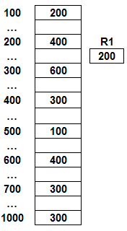

Answer: (12 marks: 1.5 marks for each correct answer)

Initially, AC=400

Mode | Value in AC after Load 300 | Value in AC after Add 400
Immediate | 300 | 700
Direct | 600 | 900
Indirect | 400 | 1000
Indexed | 100 | 500

- Answer the following questions: [14 marks]

- Find the values of (-36) and (-82) in 8-bits binary representation using One’s Complement representation. (6 marks)
- Find the sum of (-36) and (-82) in 8-bits binary representation using One’s Complement representation. (4 marks)
- Convert the calculated sum from C1 to decimal and deduce whether it is correct or not.

Answer: (14 marks)
a) (6 marks)
-36= 11011011 (C1) (3 marks)
-82 = 10101101 (C1) (3 marks)

b) (4 marks: 3 marks for the addition, showing that the carry-out 1of the 8th bit is added; 1 mark for the final result).
1
11011011
+ 10101101
10001000
1
10001001
- The result is correct (-118): 10001001_{C1}= -(01110110) which is -118. (4 marks)

- Assume that we have a system with a memory of 128M words. Blocks are 32 words in length and the cache consists of 32K blocks. [14 marks]

- How many blocks are there in the main memory?

Draw the format of the memory address as seen by the cache, showing the fields as well as their sizes, for the following schemes:
    - Direct Mapped Cache.

    - 16-way set associative cache mapping scheme

Answer:
- Number of blocks in main memory= 2²⁷/ 2⁵= 2²² blocks (4 marks)
- Each address has 27 bits, and there are 7 in the tag field, 15 in the block field and 5 in the word field. (5 marks: 1.5+1.5+2)

7 | 15 | 5

- Each address has 27 bits, and there are 11 in the tag field, 11 in the set field and 5 in the word field. (5 marks: 1.5+1.5+2)

11 | 11 | 5

_____________________________________________________________________________
End of Questions

