

Faculty of Computer Studies

T103/TM103
Computer Organization
and Architecture

Final Examination V1 Solution

Fall 2021-2022

Date: TBA

(1) Hour | Time Allowed: | (6) | Number of Exam Pages:  ((including this cover sheet
Total Grade: 50

Instructions:

1- Write all your answers on the Answer Booklet.
2- Programmable calculators are not allowed.

Question Type | Number of questions | Max. Mark | Estimated time
MCQ | 25 | 50 | 60 minutes
Total |  | 50

MCQ: Answer ALL the following questions (50 marks)

Instructions: This part consists of 25 questions carrying a weight of two marks each.

Carefully read each question, and choose the most correct answer :

- Assume that the clock frequency for a CPU is 500 MHz, which of the following values is the clock cycle time for this CPU (in seconds)?

- 1/500 s.
- 500 s.
- 1/(500,000,000) s.
- 500,000,000 s.
- 1/(500,000) s.

- In the computer hierarchy diagram, level ___ relates to where the user executes programs.

- 5
- 0
- 1
- 6
- 7

- Which gate does the following Boolean expression represent? X = (A + B)'

- NAND
- XOR
- OR
- NOR
- De Morgan’s

- Which gate produces a 0 only if all its inputs are the same and a 1 otherwise?

- AND
- NAND
- XOR
- OR
- Both b and c

- A flip flop that is used to build registers is called:

- D Flip Flop.
- JK Flip Flop
- RS Flip Flop
- T Flip Flop
- Both a and d.

- If we have a 64K * 16-bit memory module (Byte addressable), then the needed number of address lines is:

- 15.
- 19
- 17
- 27
- 16.

- What is the complement of the expression ab’+c?

- (a + b)' .c'
- (a'+b).c'
- (ab)'. c'
- a'+b+c'
- None of the choices

- Which number system accepts 1010 as a valid number.

- Binary.
- Octal.
- Decimal.
- Hexadecimal.
- All choices.

- Which of the following is not a CPU component?

- Program Counter
- Arithmetic Logic Unit
- Main Memory
- Control Unit
- a and c .

The following four questions are related to figure 8.

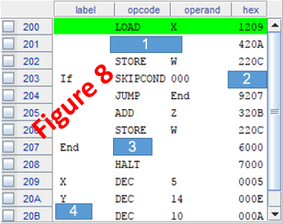

- What is the hidden instruction (1)?

- Store X
- Store Y
- Add Y
- Subt Y
- Subt X

- What is the equivalent Hex value of the instruction Skipcond 000 (2)?

- 6000
- 7000
- 8400
- 8000
- 9000

- What is the hidden instruction (3)?

- JNS
- Jump If
- Output
- End
- JUMP X

- What is the hidden label (4)?

- Else
- Z
- W
- One
- Cannot be known.

- ________ is the lowest number system in which 756 is considered a valid number.

- Binary.
- Octal.
- Decimal.
- Hexadecimal.
- All, except a.

- Given the truth table below, what will the SOP of F be?
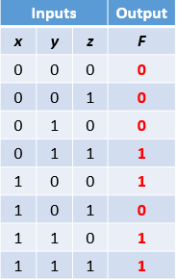

- x’yz + x’yz’ +xyz +xy’z’
- x’yz + xyz’ +x’y’z’ +xy’z’
- x’yz + xyz’ +xyz +xy’z’
- x’y’z’ + x’yz’ +xy’z +xy’z’
- None of the choices

- Given the K-map of a function F below, what will be the simplified equation of F?

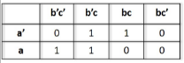
- a’b’c+ ab’
- ab + b’c + a’bc
- ab’c’ + b’c + abc
- ab’+ a’c
- None of the choices

- Given the below logic diagram, what is the output of gate F?
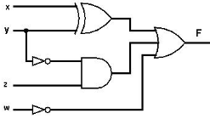

- (x⊕y) ⊕(y’. z) + (w)
- (x+y) ⊕ (y’+z) + (w’)
- (x⊕y) + (y’+z) (w’)
- (x⊕y) + (y’.z) (w’)
- None of the choices

The following four questions are related to the below problem.

Assume that we have a computer with a 1Mx16 bit main memory.
The cache memory is composed 128 blocks, and its total size is 32K bits.
Knowing that the computer uses a word addressable mode, answer the below four questions:

- How many address lines does the Main Memory need?

- 20
- 21
- 26
- 16
- 12

- How many words do we have in the Cache Memory?

- 32
- 128
- 64
- 16
- 1024

- How many blocks are there in the main memory?

- 2^18
- 2^16
- 2^10
- 2^13
- 2^15

- If we are using the 4-way set associative cache scheme, what will be the number of bits in the Set field?

- 6
- 8
- 4
- 5
- None of the choices

The following four questions are related to figure 7.
Given the below piece of MARIE’s code:

Add 200
Subt 100

You are asked to find the actual value that will be in the accumulator, AC, after executing each instruction in each mode, and fill in the table below:
Note that for each addressing mode the value of AC is initially 500, and the execution of the second instruction depends on the previous one.

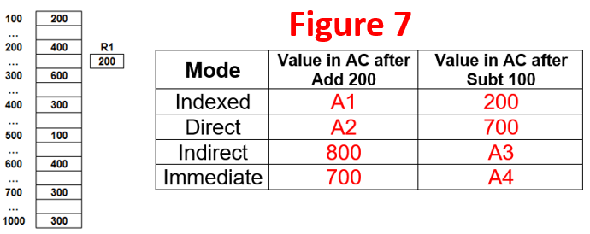

- What will be the value of A1?

- 700
- 600
- 1000
- 800
- 500

- What will be the value of A2?

- 900
- 800
- 700
- 400
- 500

- What will be the value of A3?

- 100
- 500
- 300
- 200
- 400

- What will be the value of A4?

- 500
- 400
- 600
- 200
- 300

____________________________________________________________________
End of Questions

