1. **Series-parallel combination:** Assemble the circuit in figure 2-1 with the component values shown in table 2-1. Use Vs=10V. Take measurements to complete the entries corresponding to the experimental values.

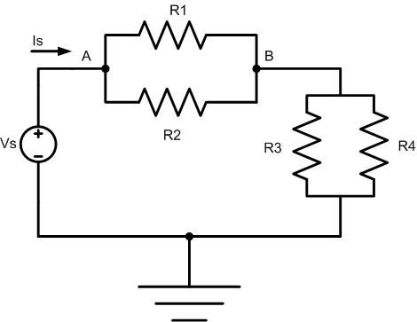

**C**

Fig 2-1: Series-parallel combination.

|  |  |  |  |  |  |  |  |  |  |
| --- | --- | --- | --- | --- | --- | --- | --- | --- | --- |
| Parameter | Unit | Theor | Exper | %Error | Param | Unit | Theor | Exper | %Error |
|  | KΩ | 1.8 |  |  |  | mA |  |  |  |
|  | 2.7 |  |  |  |  |  |  |
|  | 3.9 |  |  |  |  |  |  |
|  | 9.1 |  |  |  |  |  |  |
|  |  |  |  |  |  |  |  |
|  | V |  |  |  |  | V |  |  |  |

Table 2-1: Resistors in series-parallel combination

1. **Voltage and Current divider:** Assemble the circuit in Fig 2-4 with the component values shown in table 2-2. Take measurements to complete the entries corresponding to the experimental values.

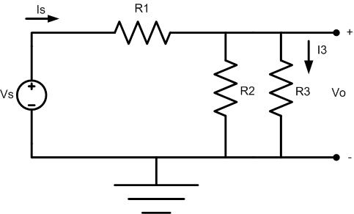

Fig(2-2): Voltage and Current divider

|  |  |  |  |  |  |  |  |  |  |
| --- | --- | --- | --- | --- | --- | --- | --- | --- | --- |
| Parameter |  |  |  |  |  |  |  |  | Req |
| Units | KΩ | | | V | | mA | | | KΩ |
| Theoretical | 1.8 | 2.7 | 3.9 | 10 |  |  |  |  |  |
| Experimental |  |  |  |  |  |  |  |  |  |
| %Error |  |  |  |  |  |  |  |  |  |

Table 2-2: Voltage and current divider