**Construct the circuit shown below:-**

|  |  |  |
| --- | --- | --- |
| R | Theoretical Value (Kohm) | Measured Value |
| R1 | 3.3 |  |
| R2 | 6.2 |  |
| R3 | 1.2 |  |
| R4 | 2.7 |  |

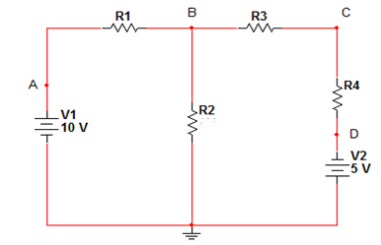

* **Nodal Analysis:**

|  |  |  |  |  |
| --- | --- | --- | --- | --- |
| Value | VA | VB | VC | VD |
| Measured |  |  |  |  |
| Theoretical |  |  |  |  |

1. Use the Nodal Analysis to find the theoretical values.

* **Superposition Analysis:**

|  |  |  |  |  |  |  |  |  |
| --- | --- | --- | --- | --- | --- | --- | --- | --- |
| Value | $${VB}^{'}$$ | $${VB}^{''}$$ | $${VC}^{'}$$ | $${VC}^{''}$$ | $${I1}^{'}$$ | $${I1}^{''}$$ | $${I2}^{'}$$ | $${I2'}^{'}$$ |
| Measured |  |  |  |  |  |  |  |  |
| Theoretical |  |  |  |  |  |  |  |  |

1. Use the Superposition Analysis to find the theoretical values.