* **Construct the circuits shown below and answer the following questions.**

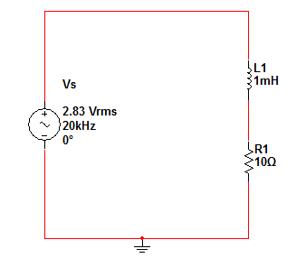

1. **RL Circuit**
$V_{L} \left[ lag, Lead, In phase\right]with I_{L} ?$

$Find the magnitude of V_{L} , V_{R} and I_{L} ?$

$Find the phase shift between V_{s} and I_{s} ?$

$Plot V_{s} and I_{s} on the same graph ?$

2. 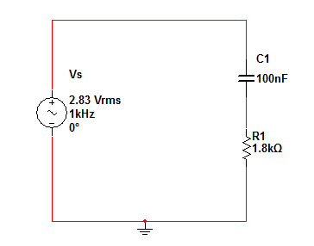**RC Circuit**

$V_{C} \left[ lag, Lead, In phase\right]with I_{C} ?$

$Find the magnitude of V_{C} , V_{R} and I_{C} ?$

$Find the phase shift between V_{s} and I_{s} ?$

$Plot V_{s} and I_{s} on the same graph ?$